BSCS FINAL PROJECT

<Digital Constructions>



Project Advisor

**<Muhammad Bilal Khan >**

Presented by:

**Group ID: F22S023**

**Student Reg# Student Name**

|  |  |
| --- | --- |
| L1F19BSSE0235 | Muhammad Saim |

**Faculty of Information Technology**

**University of Central Punjab**

Complete System

SDP Phase IV

Digital Construction

Advisor: Muhammad Bilal Khan

Team <Team # F22SE023>

Table of Contents

Table of Contents i

Revision History ii

Abstract iii

1. Introduction 4

1.1 Product 4

1.2 Background 4

1.3 Objective(s)/Aim(s)/Target(s) 5

1.4 Scope 5

1.5 Business Goals 6

1.6 Document Conventions 6

1.7 Miscellaneous 7

2. Technical Architecture 7

2.1 Application and Data Architecture 8

2.2 Component Interactions and Collaborations 13

2.3 Design Reuse and Design Patterns 18

2.4 Technology Architecture 18

2.5 Architecture Evaluation 18

3. Detailed/Component Design 19

3.1 Component-Component Interface 19

3.2 Component-External Entities Interface 20

3.3 Component-Human Interface 21

4. Screenshots/Prototype 39

4.1 Workflow 39

4.2 Screens 40

4.3 Additional Information 56

5. Other Design Details 57

6. Test Specification and Results 57

6.1 Test Case Specification 57

6.2 Summary of Test Results 67

7. Project Completion Status 68

8. Deployment/Installation Guide 69

9. User Manual 71

10. References 73

11. Project Summary Form 74

Appendix A: Glossary 92

Appendix B: IV & V Report 93

Revision History

|  |  |  |  |
| --- | --- | --- | --- |
| **Name** | **Date** | **Reason For Changes** | **Version** |
| M. Saim | 5-2-2023 | Phase 2 SDS I changed AI CHATBOT to direct they message to the user. Just because this make the more cost and we don’t have enough resources. | Phase3 |
| Humza Naeem | 5-2-2023 | We are change the Node Js to Laravel for the backend we don’t have enough resources and already work on sockets but when we implement sockets system hard to handle and we don’t have enough resources. | Phase 3 |

# Abstract

It is the Web based solution we are creating Web Application which will help in almost every aspect of construction work. Different problem people face while build to find best constructor, best material rates, authentic verification and documentation, material rates updates, daily wagers and many more Similar it is same as for builders to find difficulty to have job.

It will help user to find the best rate for construction and not only it will provide you the best rates of constructors but it will give you complete details of the market in which you product is present like it will provide you basic information as well as the concrete information which every user needs while investing such huge amount. Like we provide the clients the best suitable constructor for that category like residential and commercial buildings.

Verified Builders companies are here which is verified through admin by FBR federal board of revenue and SECP Securities and Exchange Commission of Pakistan. Materials are check and verified by the Civil Engineers.

# Introduction

As per Digital World has been equipped us all over and we are living in digital ERA and also seems our future has good bond with the term Digital Futuristic. Clients will be our main audience because our Web will provide major facilities to our clients and we will include numbers of daily wagers in our Web Project which will help clients to directly contact them. When they sign in the web module, they will get the different constructors/builders completed and on-going projects details and what they can do for a customer. One of the key benefits of digital construction web app is that they allow all stakeholders, including contractors, architects, engineers, and owners, to access and share project information in real-time, from anywhere in the world. This can improve transparency, reduce errors, and facilitate more efficient decision-making. User can make different deals and offers from constructors/builder and there will be meeting between them through Web Module [5] (Kannan, 2020).This Chatbot is fully efficient they reply according to user mode. There is no Web based platform for user to check construction management and construction market before. This platform provides the Verified Builders their FBR certificate user easily see and SECP verified. Motivation of this work behind is Provide the Best Quality products [6] (Demski, 2022), verified Builders and Civil Engineers for the ease our users.

## Product

Problem people face while building home to find best constructor [4], best material rates, authentic verification and documentation, material rates updates, daily wagers and many more Similar it is same as for builders to find difficulty to have job. Lack in builders verification this is verified builder or not. Fake Documentation of the product poor quality construction materials (and equipment tools). Different rates are given in MARLA But every city has change in SQUARE FEET Like Lahore has 225 SQFT and Sahiwal has 272 SQFT so cost are change in every city no fix rate are there for customer ease, No check and balanced specialized builders information are there for quality work, Different shops have different material rates beyond same quality, People don't have much knowledge about classes of material Such as A+, A, B and C classes. Builder portfolio is not verified. Problems specially faced Female if they want to build their home this is very difficult for the females to finds all these things. Build your construction too much time consuming It take a lot of time this is very hard for Persons. Overall, the goal is to improve collaboration, efficiency, and safety in the construction industry, ultimately leading to better project outcomes and higher client satisfaction.

## Background

Our Country Pakistan has to offer a unique variety of digital construction. Our research shares the opinion that the trend of digital construction in Pakistan is witnessing a boom which is likely to continue into the future as well locally. This trend has benefitted other sectors of the economy as well, including the real estate sector and small businesses. But the problem is that the digital construction are facing problems in a way Such as In recent time, the construction industry has faced a number of challenges: Climate change, sustainability, lagging productivity and financial pressure. The construction incumbents are still formulating a response to these trends when planning for a construction, client says that the information is scattered. It is mostly all available on the internet but trying to peruse through everything is time consuming and some of the information is hard to find. Another problem is construction Scams. Construction scams are a distinct risk factor to construct. Most of the digital clients face problem while planning their construction. And if clients are constructing by their own stuff, and they might experience variety of labour and material problems. Digital construction could provide an answer. It is defined as utilizing digital technologies to construct more efficiently with higher quality. However, when looking at IT investments, the construction has historically underinvested in technology.

## Objective(s)/Aim(s)/Target(s)

Provide the Best Quality Products to our clients. They can Purchase the Construction materials according to their budget. They Know where they want to cut the cost and which part they use which Quality material. Material Quality all details they can check. Client appoint the builder they can also check their FBR Certificate. Admin Check Builder is must Verified by FBR Federal Board of Revenue and SECP Securities and Exchange Commission of Pakistan. This help client a lot for appoint the builder. User first appoint the verify builder so they don’t have any doubt’s they use the other materials still if they want to check this material Adding a feature Home inspection. In his feature Civil Engineers are register for inspection materials and construction. Admin verify their Degree .In this Person is appointed to user then user send the all materials details send to appointed person so they inspect the material it is valid material which they use. They send report to user. This feature is Home Inspection. In market the shops sell the material by taking the margin 40-60% with this user direct order through company without no time waste or other add expense like petrol one city to other city. All the Facilities under one roof. Our DIGITAL CONSTRUCTION FBR Certificate also users can check.To improve collaboration and communication among stakeholders in the construction process.To automate and streamline various construction-related tasks, such as project planning, scheduling, and resource allocation.To enable better project management, risk management, and change management, reducing the likelihood of delays and cost overruns.To increase efficiency and productivity in the construction industry by reducing manual processes and automating repetitive tasks.To improve project outcomes by facilitating better communication and collaboration among stakeholders. To increase the adoption of digital technologies in the construction industry.To improve the reputation and competitiveness of construction companies that use digital construction web apps.

## Scope

"DIGITAL CONSTRUCTION" is a project which is taken into existence with some mature reasons. These reasons are also connected with the scope of this project in the future. The Digital Construction is a Web based that helps people plan amazing construction ideology. We see this project to have a vast scope in the future once it is determined. The world is becoming digital day by day even construction is the only thing that asks very serious knot in one’s life. There is always a new designs to construct with uniqueness in it, and there's always something wonderfully new to be found. We are here to Provide people ease with these features:

● Contraction guide

● Construction cost sharing

● Material updates

● Weather conditions on construction days

● Contact info

● Budget guider

● Contact list of labor

## Business Goals

Better Productivity. One of the greatest benefits is the increased productivity that comes from digitization

When the product is digital or doing work on platform where the time is updated the results and revenue both will practice with good graphs

• **Improved Safety**

Under the sake of digital construction the each and every move taken by client and constructor will be secure and save under the record will be send time to time move

• **Customer Communication**

Communication will be advanced and records will be provided the online team will work to have experience with accuracy

• **Greater Accuracy**

Exact and on time work will remanded to have fantastic results it might have time saving and good performance capability

• **Constant Innovation.**

Constant innovative will lead have a success graph with positive remarks

the most significant benefits and earning to be derived from digitalization in the industry includes time-saving in construction projects delivery, increase productivity, increase speed of work, increase document quality, speeding up of response time, and simpler working methods.

## Document Conventions

Heading size 14 font use Times

Sub heading use Times new roman size 12

All the text are times new roman size 12

Verdana font use in Use case

## Miscellaneous

JWT is commonly used for authentication and authorization purposes in web applications and APIs. It allows for secure transmission of identity and user permissions between systems. JWTs are signed using a secret key or a public/private key pair. The recipient can verify the token's integrity by validating the signature using the appropriate key. To mitigate the risk of long-lived tokens, token refresh mechanisms can be employed where a new JWT is issued after a certain period, allowing for continued user sessions without requiring authentication.

# Technical Architecture

* **Is the system custom-built? COTS?**

It’s a COTS based system this software product that has been licensed to the general public by a commercial entity in a business of making a profite.Turnkey systems are built around a suite of commercial products.

* **What type of processing is the current system responsible for?**
* **Batch and/or online**
* **Transaction processing and/or analytical reporting**

It’s an Online type of processing. Transaction process are reads data item from storage to maindatabse, Change value of item in the main database and write the modified value from main memory to database.

* **What are the major application components?**

Application Server

Database server

* **What data does the current system collect and manage?**

Customer information: This information is used to facilitate transactions and provide personalized experiences for customers.

Product information: collect and manages data on the products sold on its platform.

* **What is the basic application architecture (layered, client/server, etc.)?**

Data is delivered through HTTP and ensures that the client-side server and the backend server are connect to the database

* **What programming language is the current system built in?**

React Js front-end

Laravel back-end

* **What is the hardware platform that supports the current system?**

It supports all the desktops, mobile and tablets

* **What database platform supports the current system?**

MYSQL supports the current system.

* **Does the system have an end-user interface? If so, what type of user interface? (e.g., browser based, thick client)?**

Admin has the end user it has interface Graphical User interface GUI (they can perform all the CRUD)

* **What is the basic network architecture (e.g., available on LAN, WAN, Internet)?**

Internet Network Architechure are using. Internet Network Architecture is the way network services and devices are structured together to serve the connectivity needs of client devices and applications.

* **Where is the system hosted (e.g., Enterprise Data Center, Other CMS Data Center, External Data Center)?**

Out system is hosting on AWS. AWS provides a wide range of modern web hosting platform provides more than 200 fully featured services from data centers located all over the world

## Application and Data Architecture

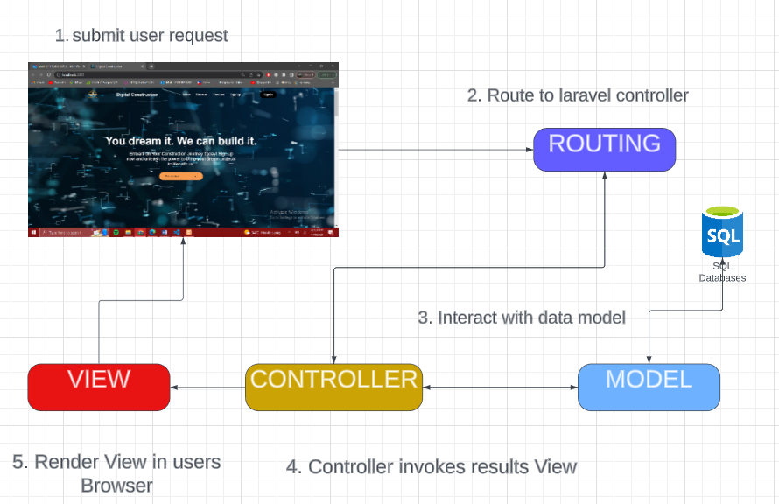

ERD

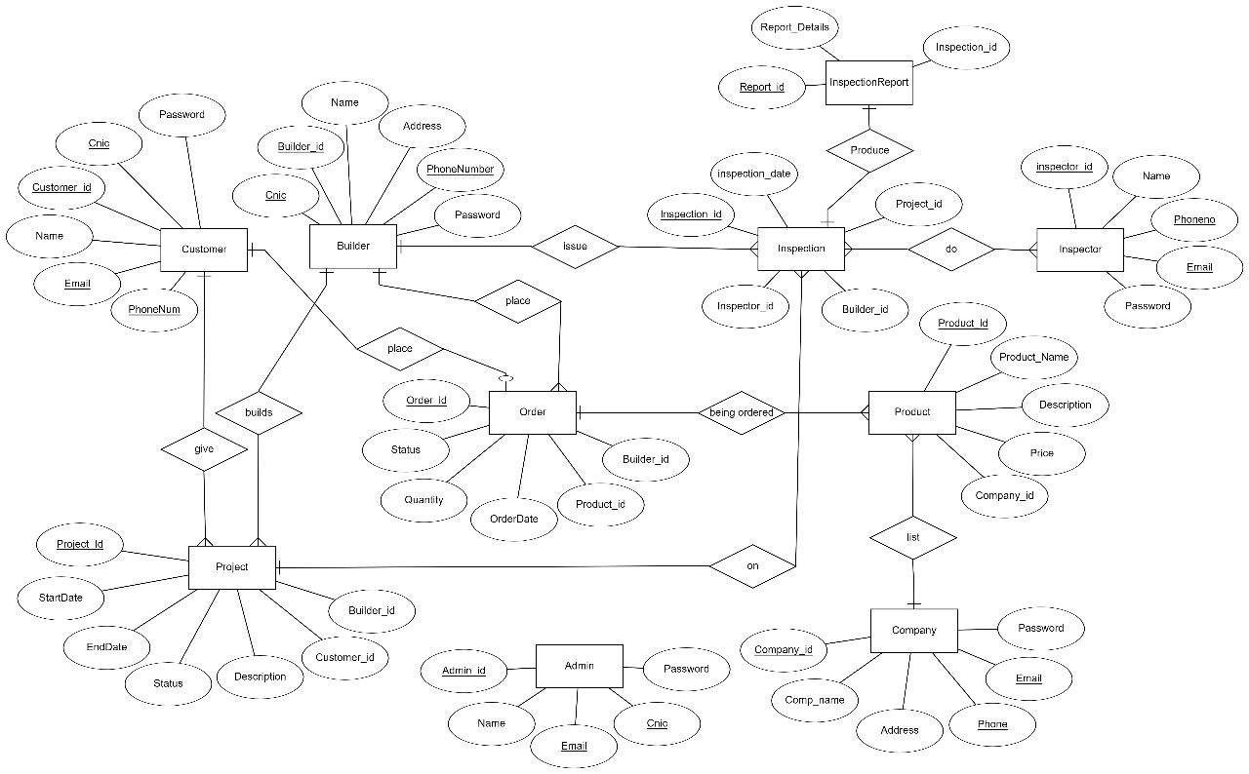

Schema

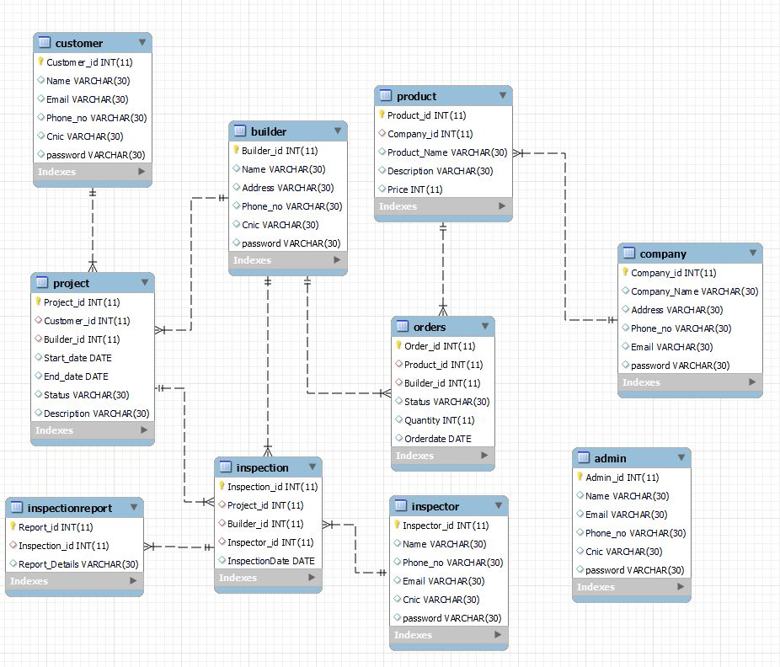

Class Diagram

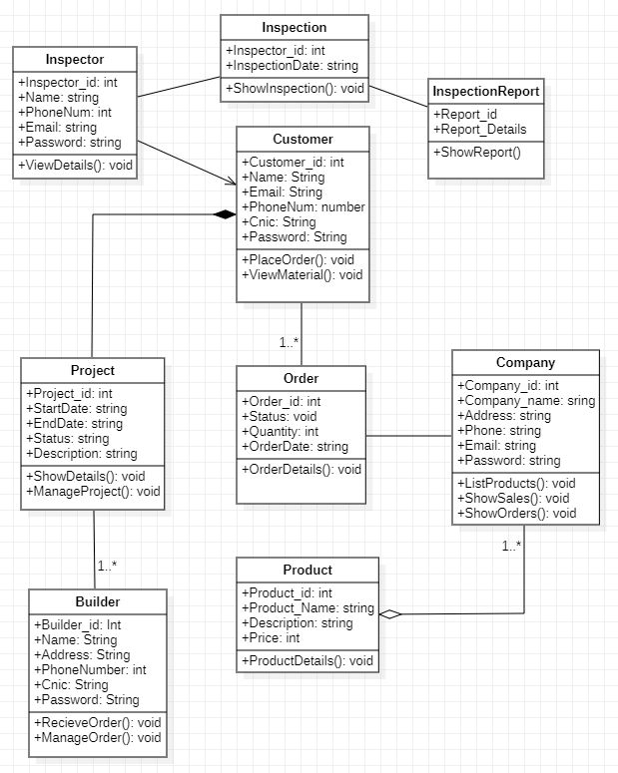

Activity

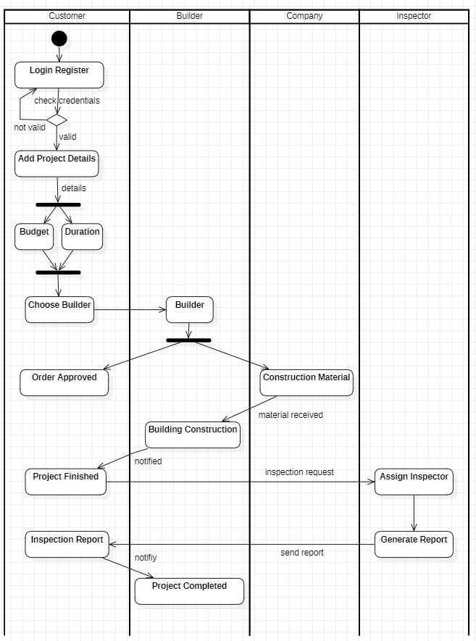

Component

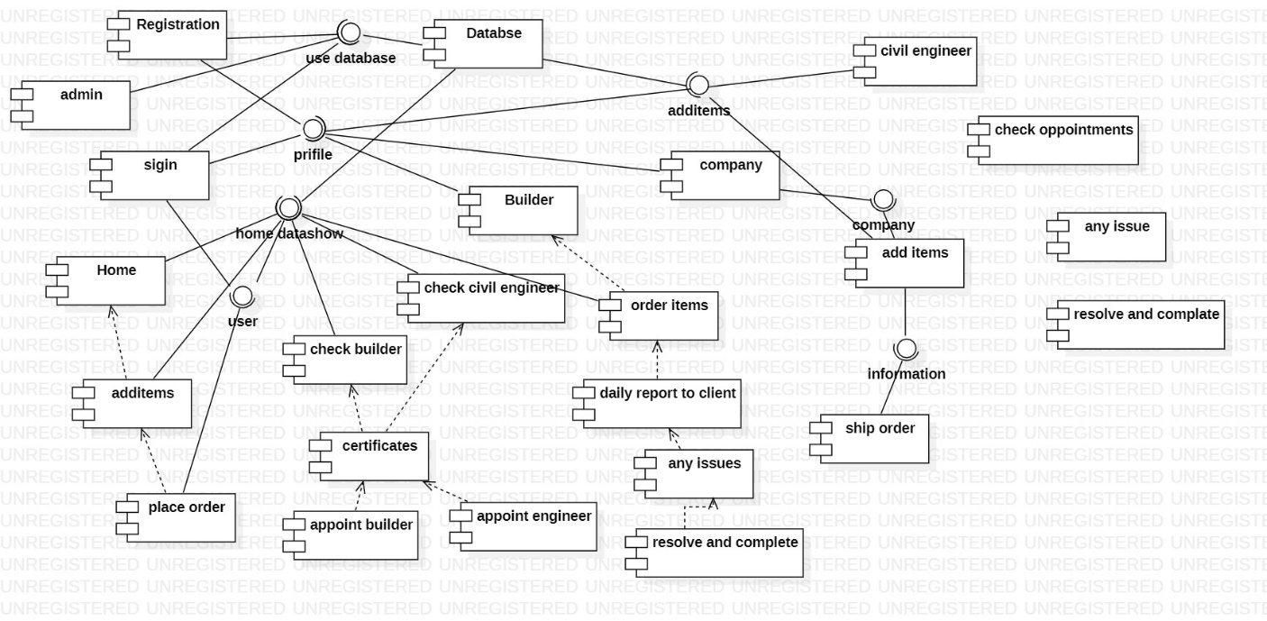

Decision Table

Eligibility Rules for use the system

|  |  |  |  |
| --- | --- | --- | --- |
| NO | UserName | Password | Eligibility |
| 1 | matched | Not matched | Not access |
| 2 | Not matched | matched | Not access |
| 3 | Not matched | Not matched | Not access |
| 4 | matched | matched | Access |
|  |  |  |  |

## Component Interactions and Collaborations

Sequence

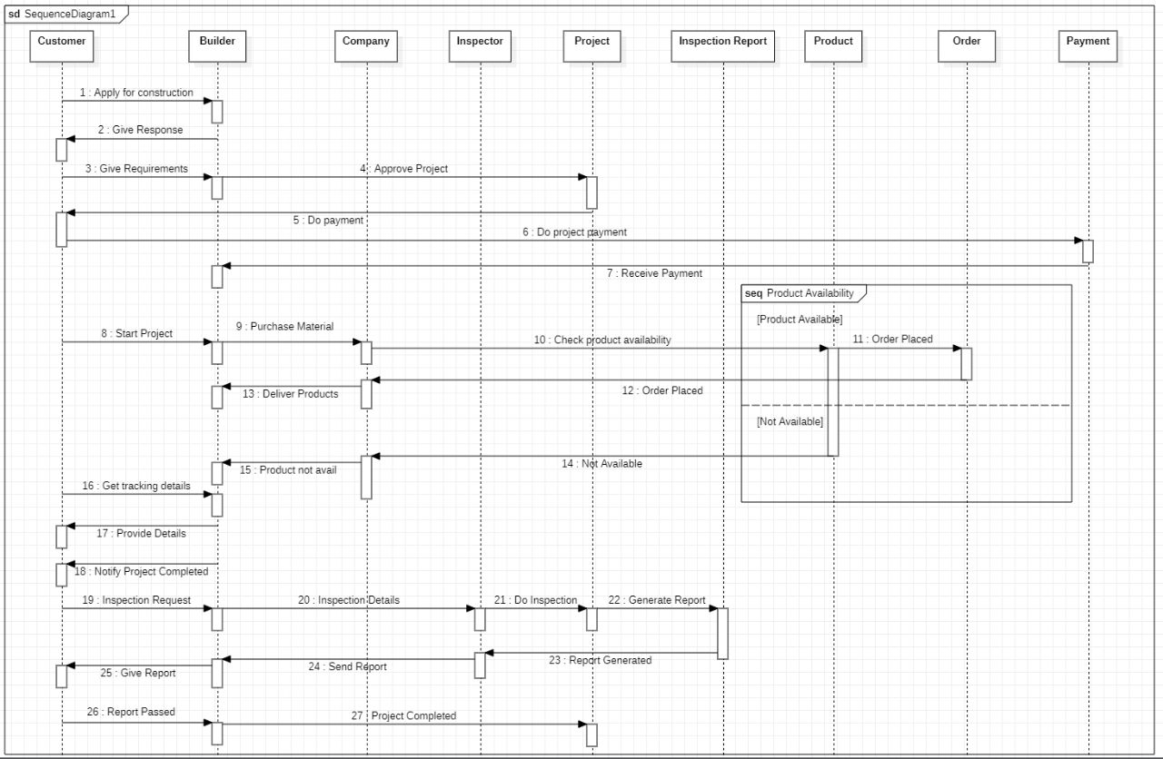

Collabration

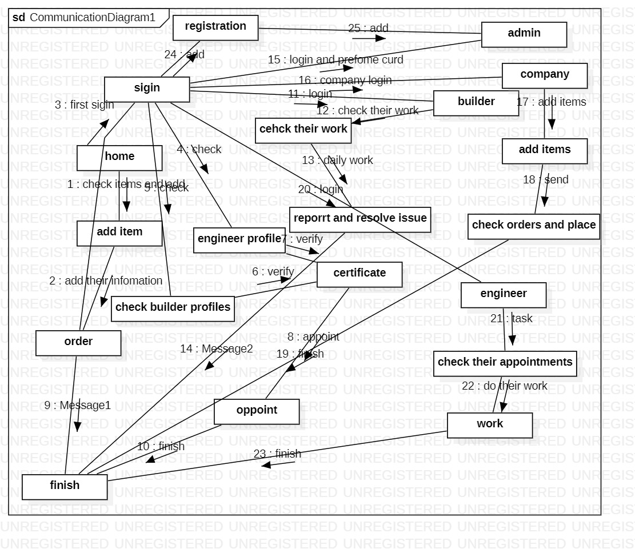

DFD Diagram

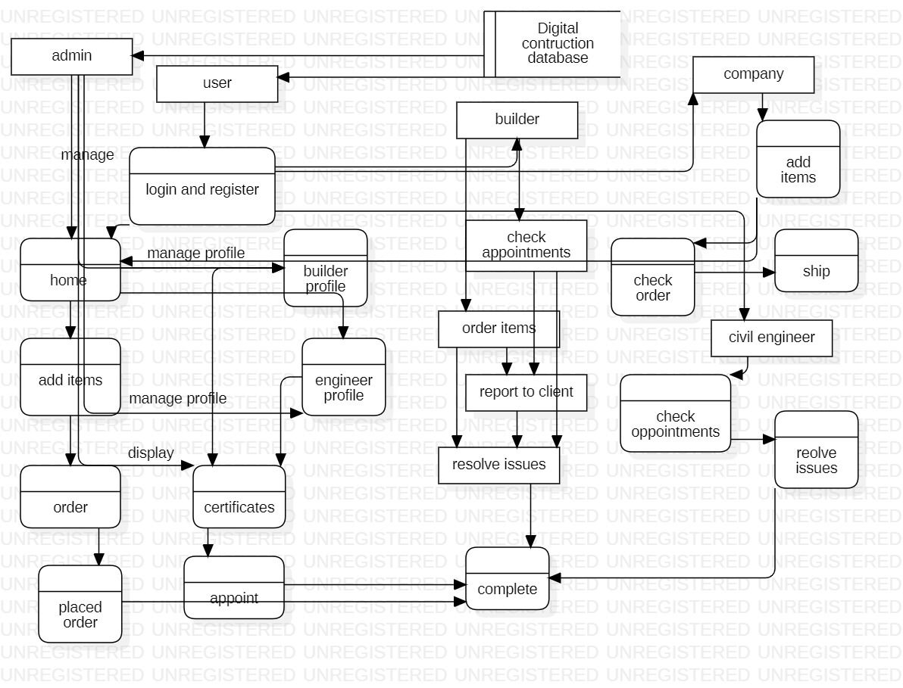

Activity Diagram.



## Design Reuse and Design Patterns

The Authentication may use their some modules are used it enhance the quality of the system and it also help for cost reduce. The Authentication can utilize various modules to improve its performance and efficiency, which can lead to a reduction in costs.

## Technology Architecture

The technology architecture for a Digital construction system involves several key components.

**System Hosting:** Out system is hosting on AWS. AWS provides a wide range of modern web hosting platform provides more than 200 fully featured services from data centers located all over the world.

**Connectivity Requirements:** The system requires a reliable/ stable and high-speed internet connection for communication. This can be achieved through a combination of Wi-Fi and cellular networks.

**Database Management:** The system uses a relational database, such as Mysql to manage information.

## Architecture Evaluation

Pros:

* Scalability: The micro-services architecture enables digital-construction to scale individual services independently, making it easier to accommodate growth and changing demand.
* Modularity: The micro-services architecture enables the development of modular, reusable components that can be shared across different applications.

Cons:

* Increased complexity: A micro-services architecture can be more complex to design, develop and deploy.
* Higher costs: Dealing with various administrations independently can prompt higher functional expenses, including framework, support, and observing.

In the case of Digital construction the decision to use a micro services architecture. this specific infrastructure and technology, several factors were considered in the decision-making process, such as performance, scalability, reliability, security, and cost. React also offers high performance and scalability, making it suitable for needs. Alternatives such as Angular and Vue.js were also considered, but React was chosen based on a thorough evaluation of each framework's strengths and weaknesses. And for the backend we are choose the Laravel and connect with the API to react its alternate is Node.js we don’t use the Node Js just because of the sockets issue while attached and also has a cost issue.

# Detailed/Component Design

## Component-Component Interface

Sequence



Collabration



## Component-External Entities Interface

The communication between components of your system and components of other systems such as

Sequence diagram attached here



## Component-Human Interface

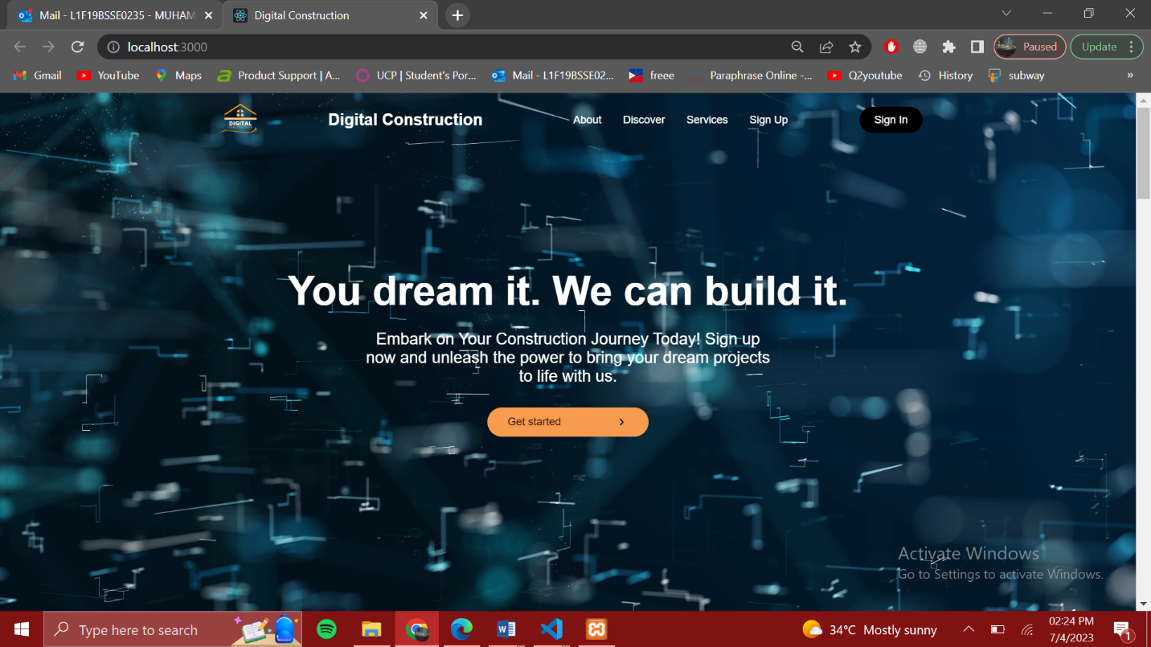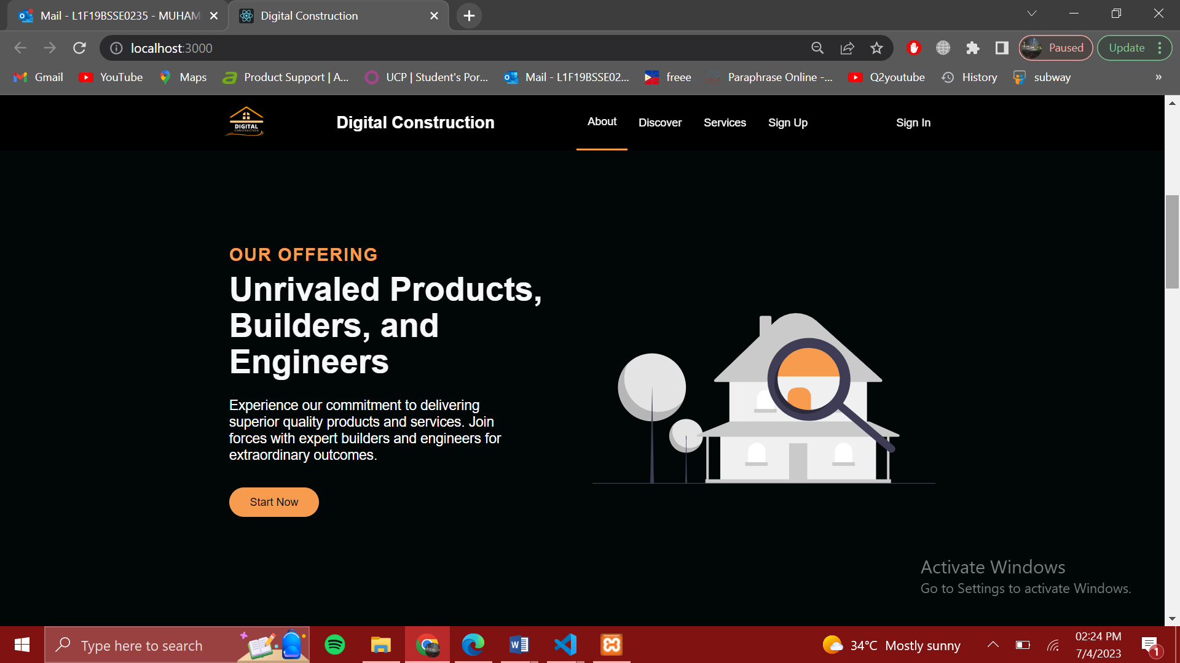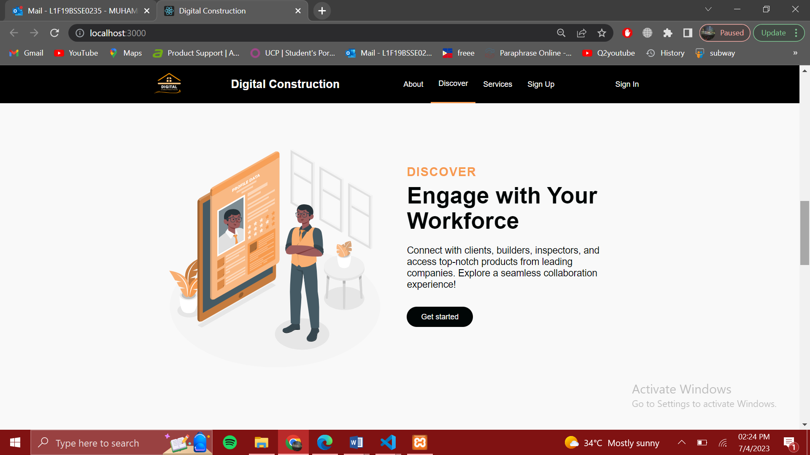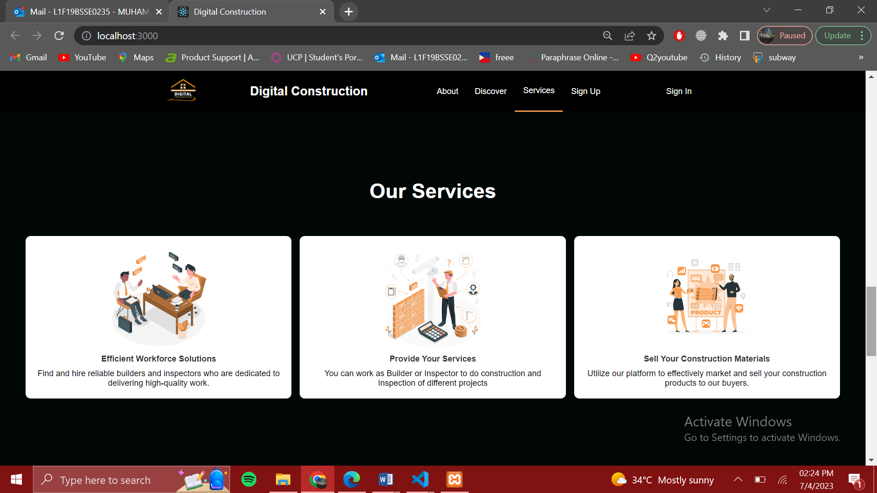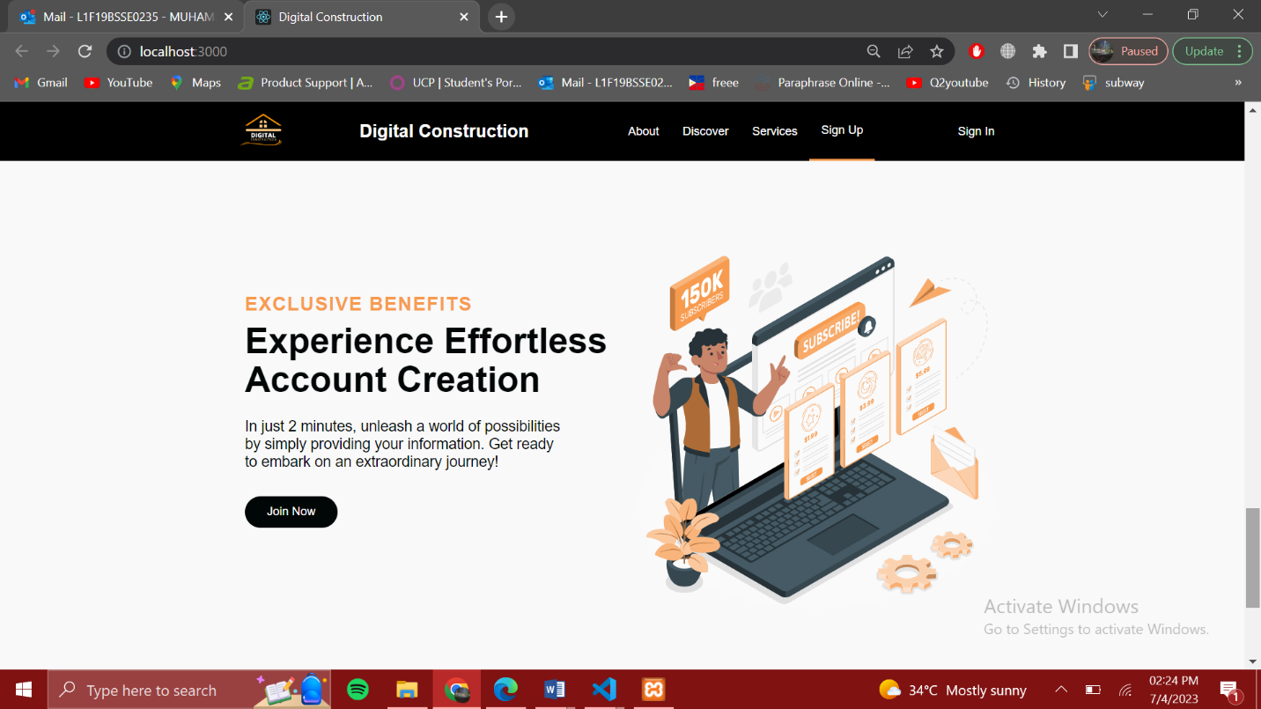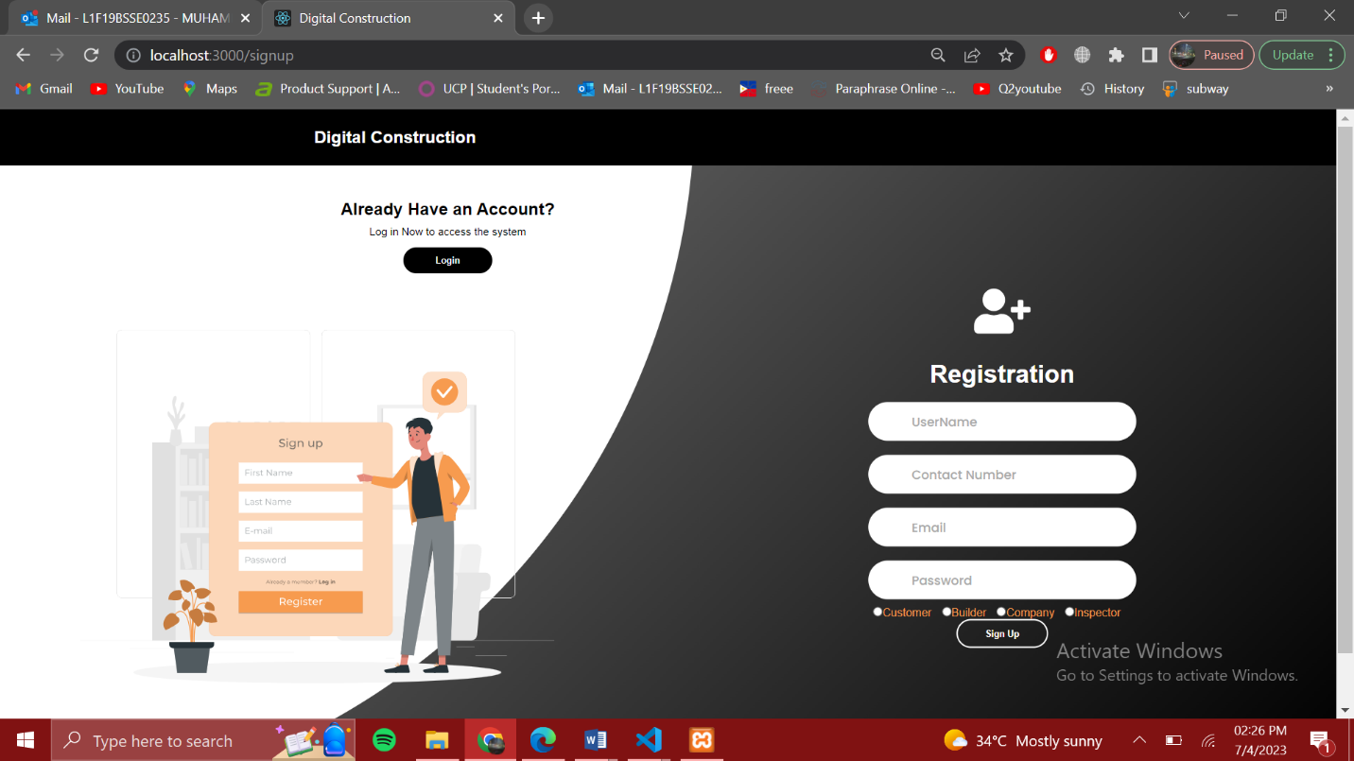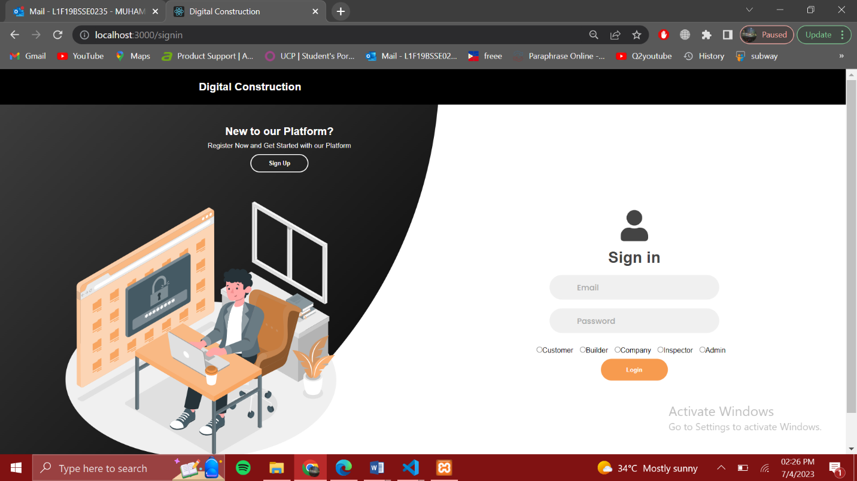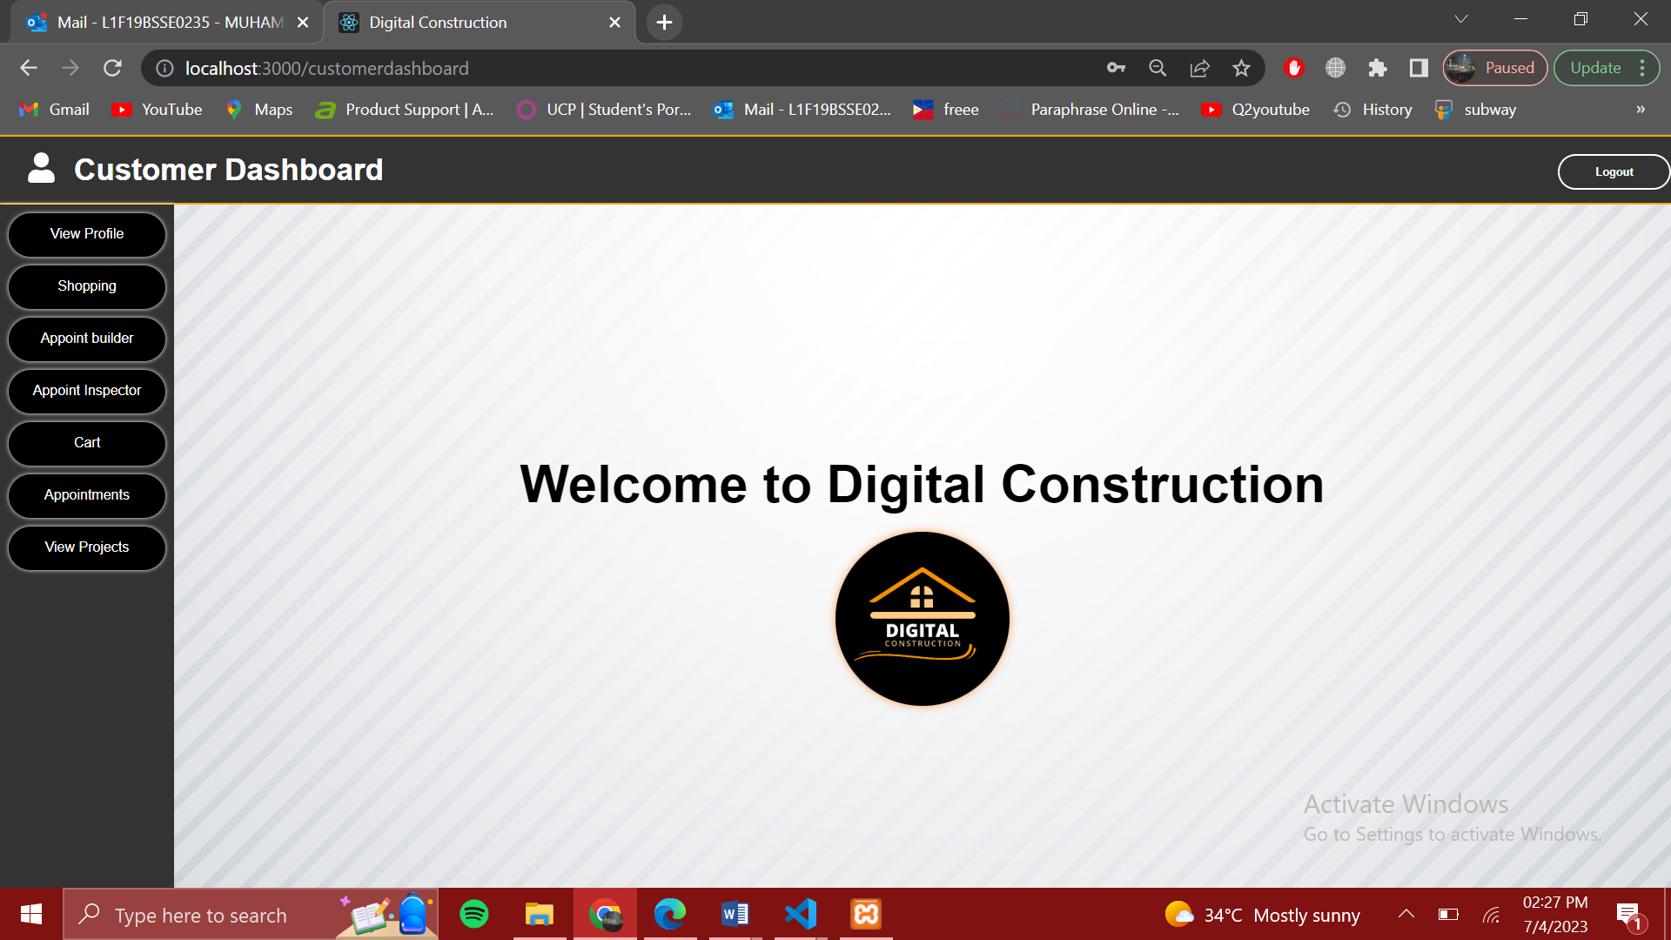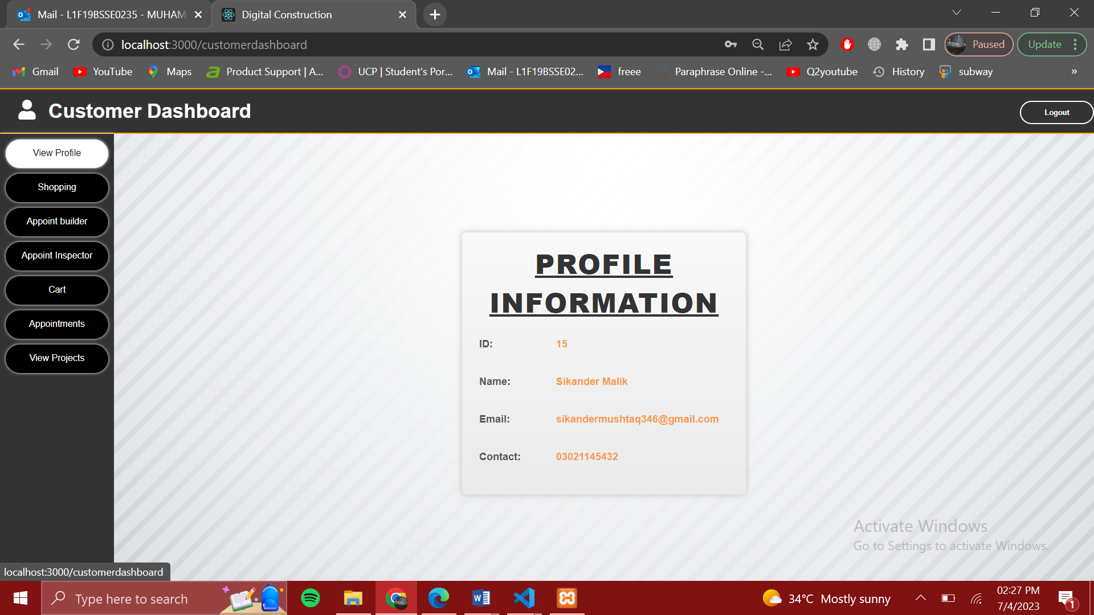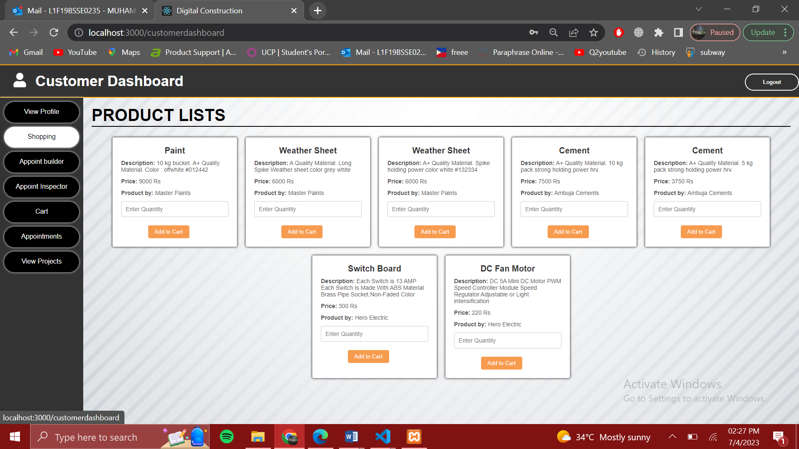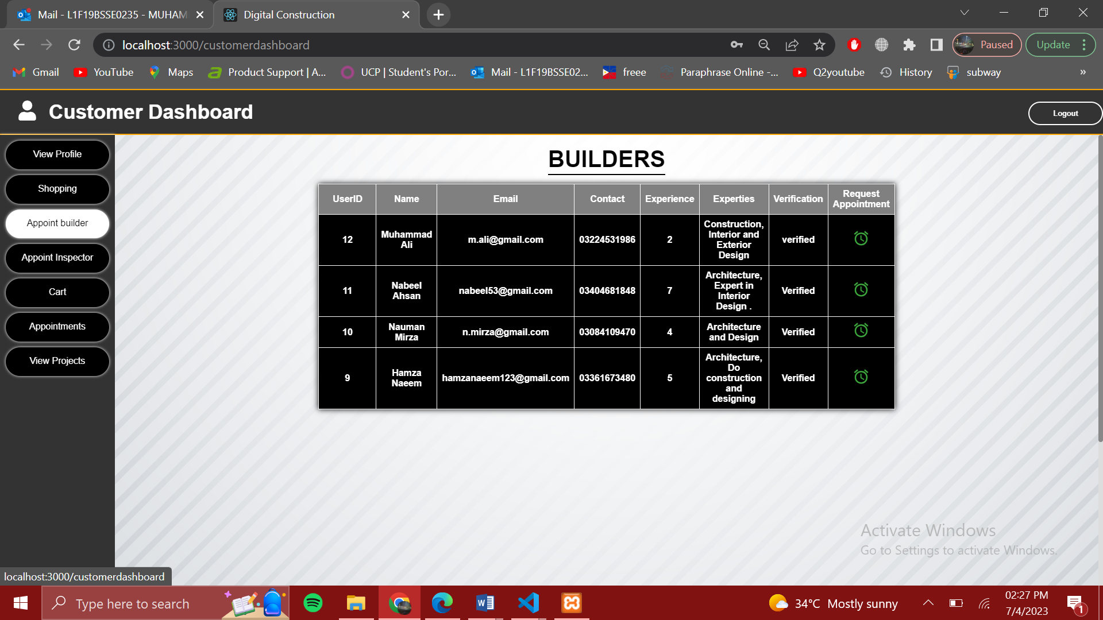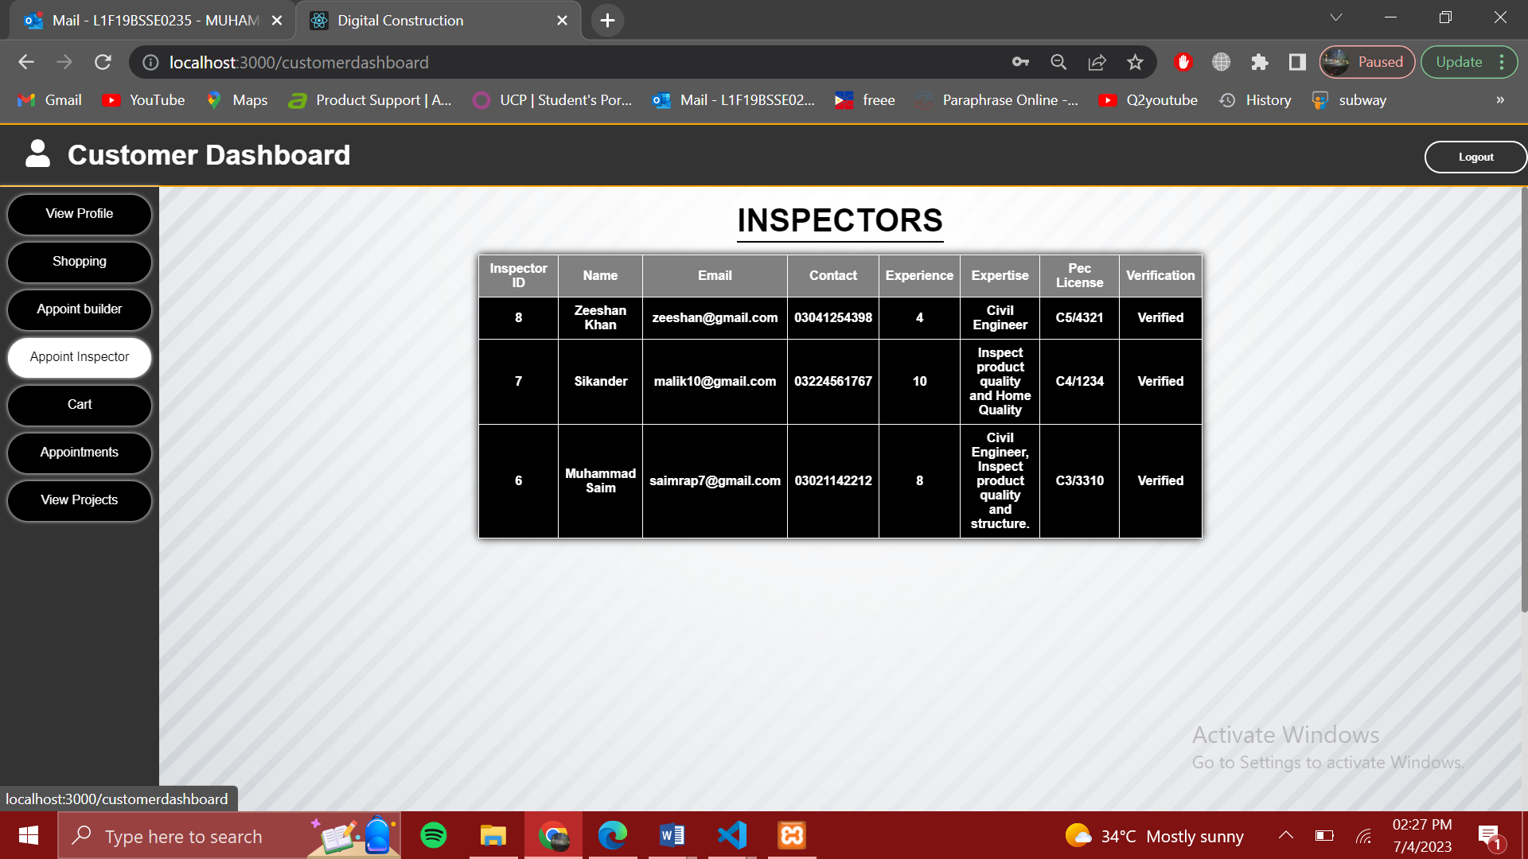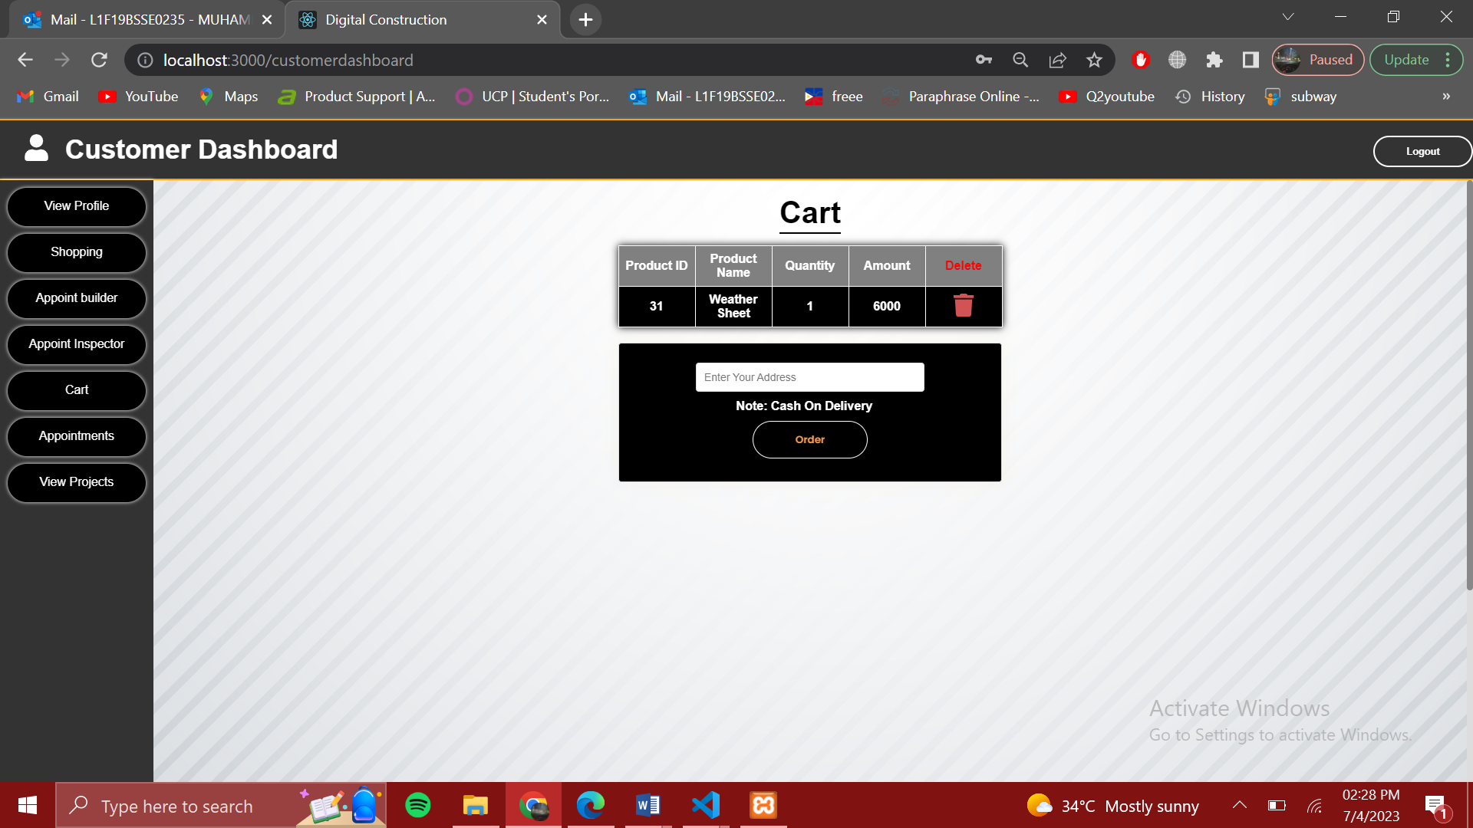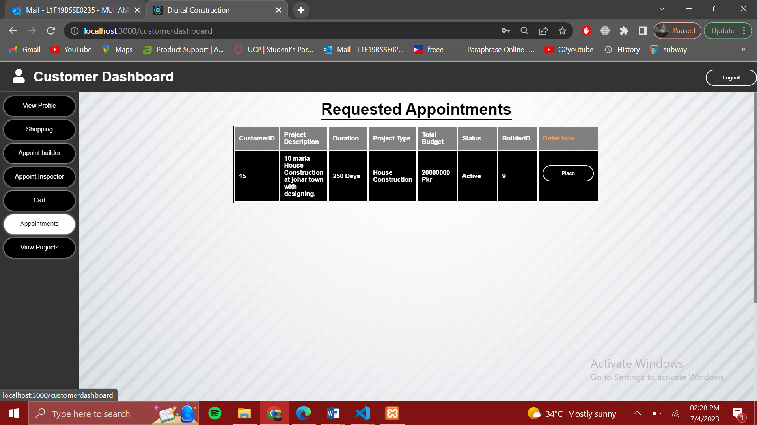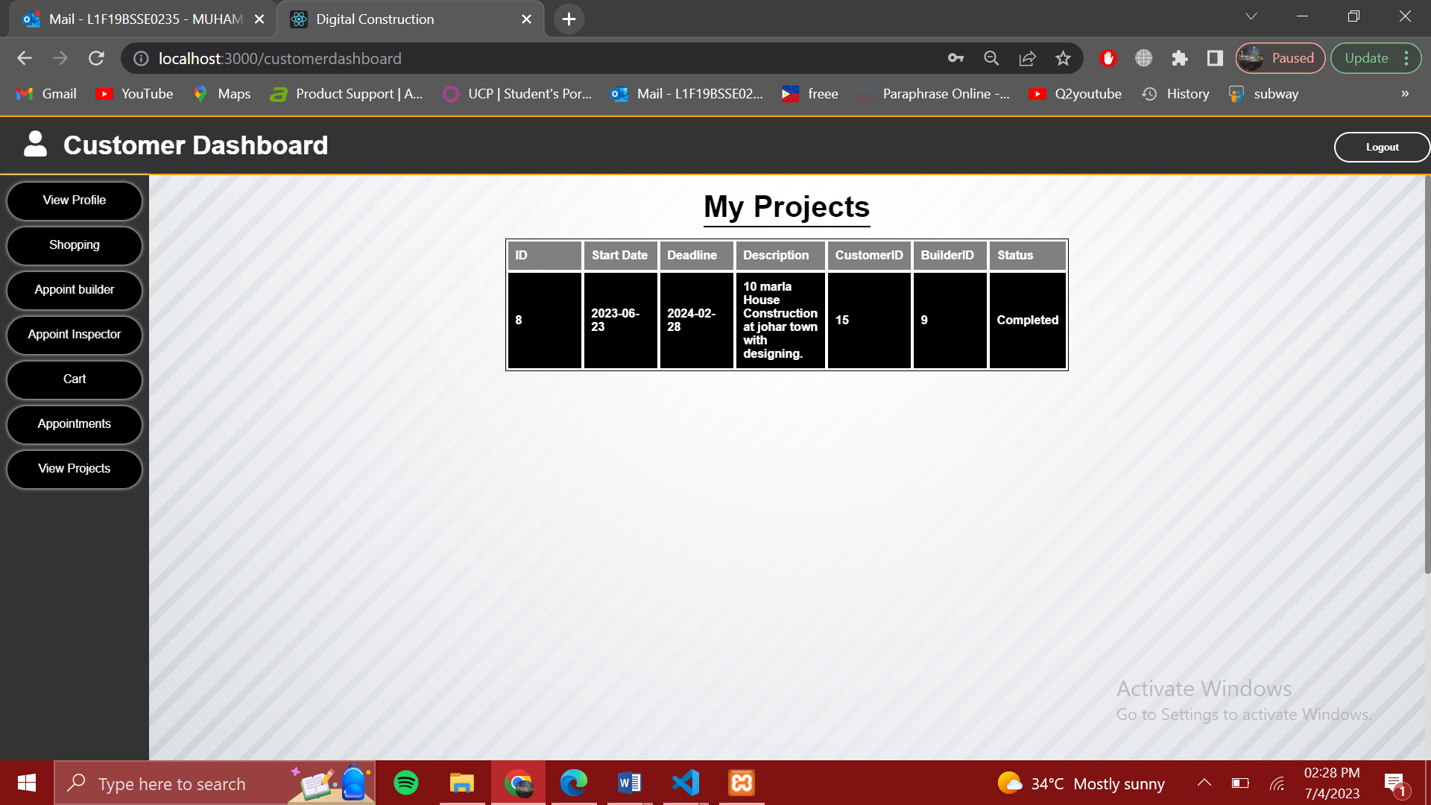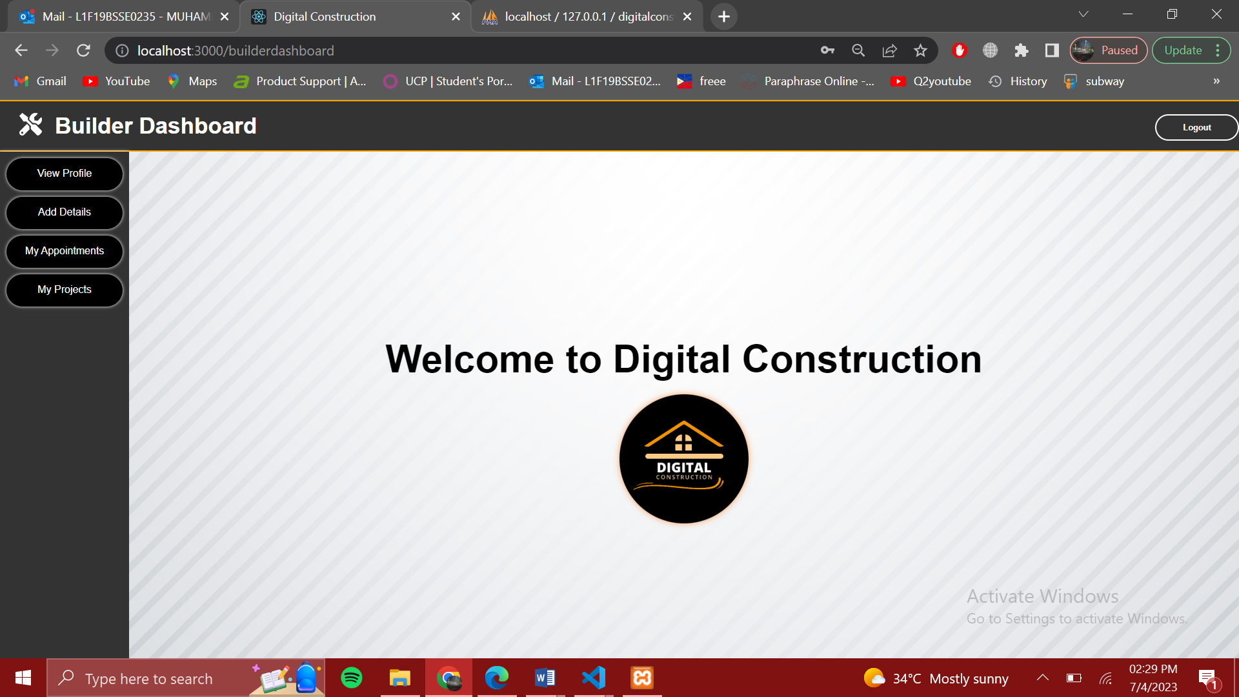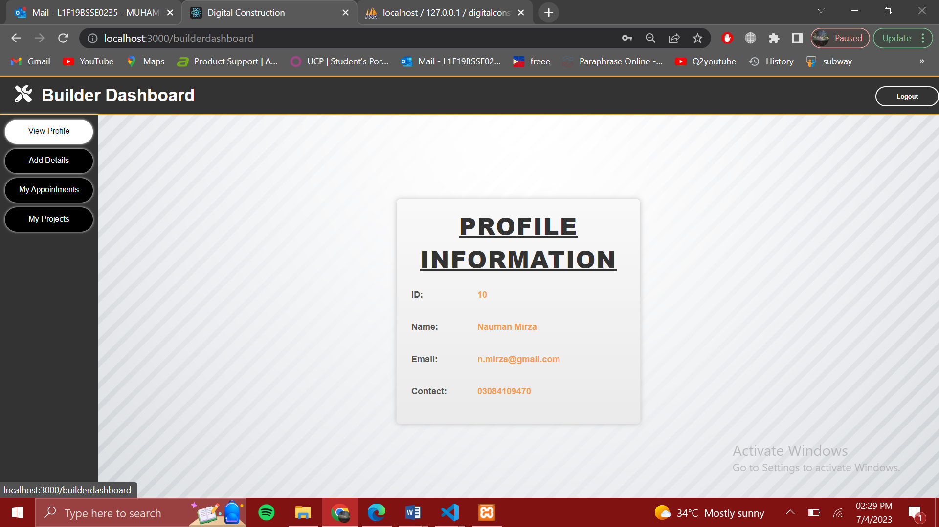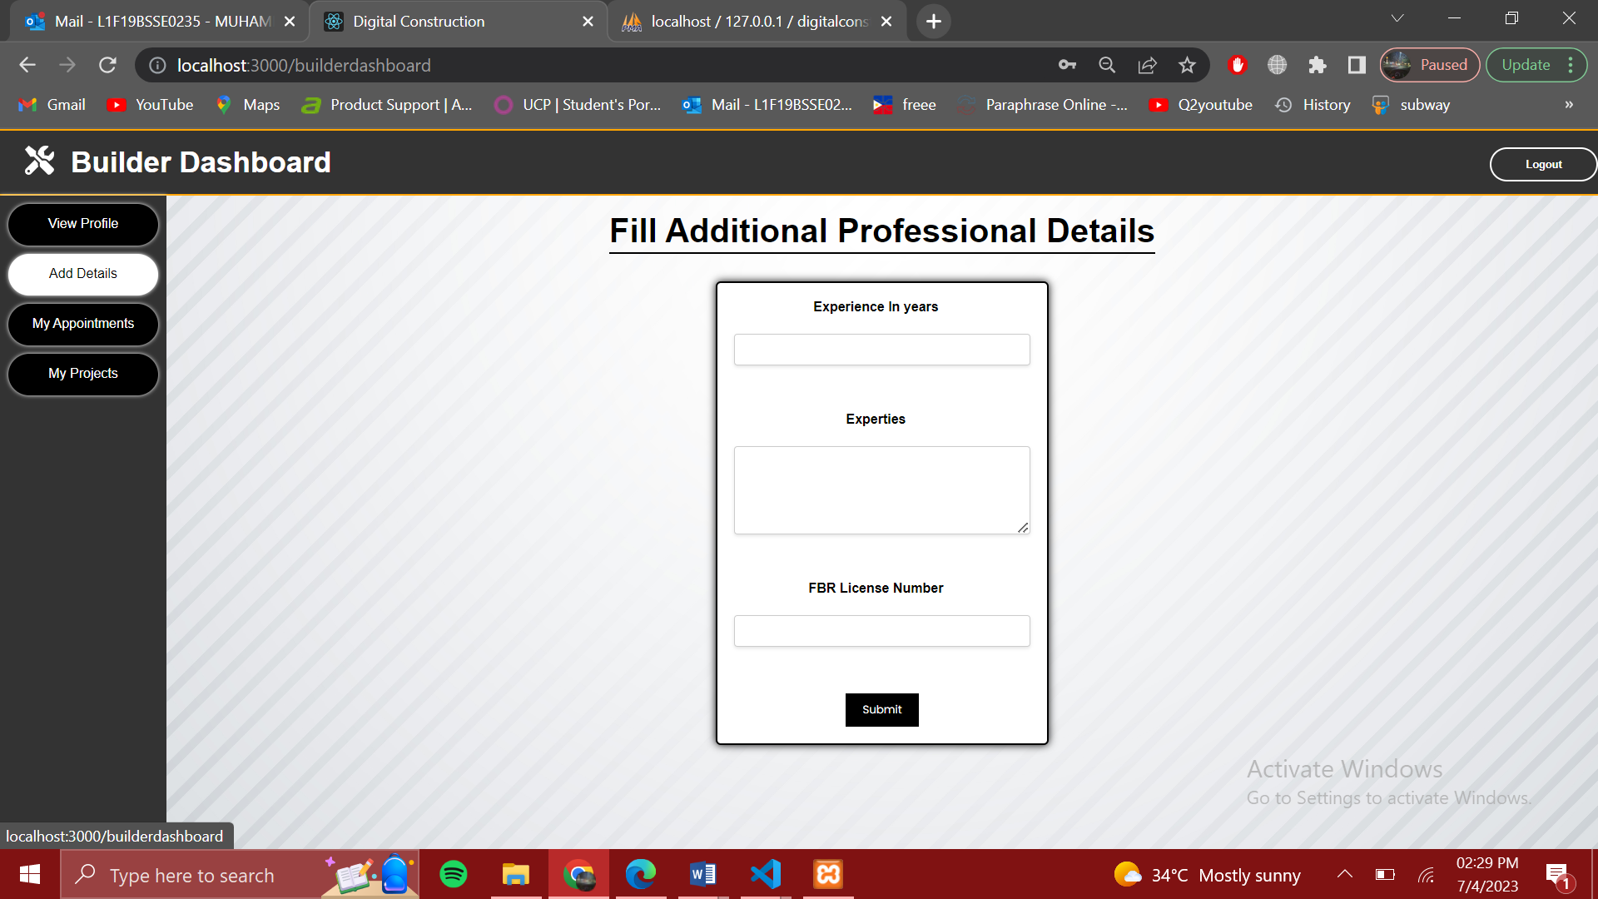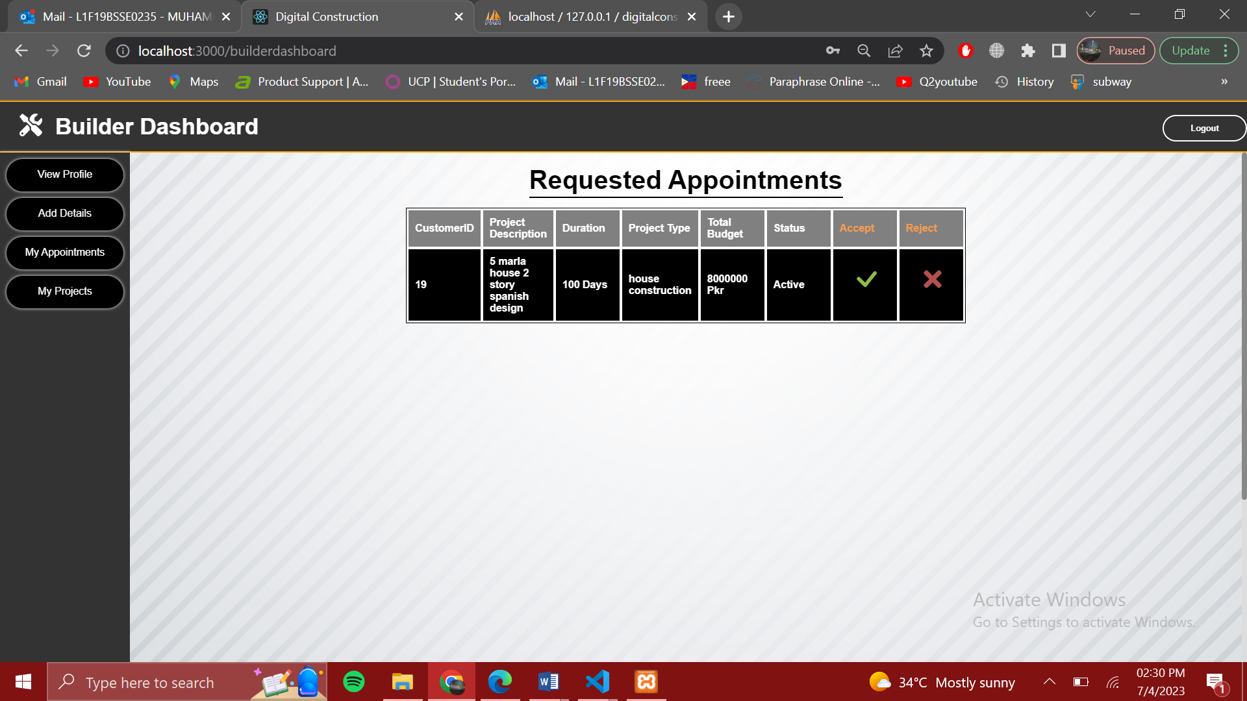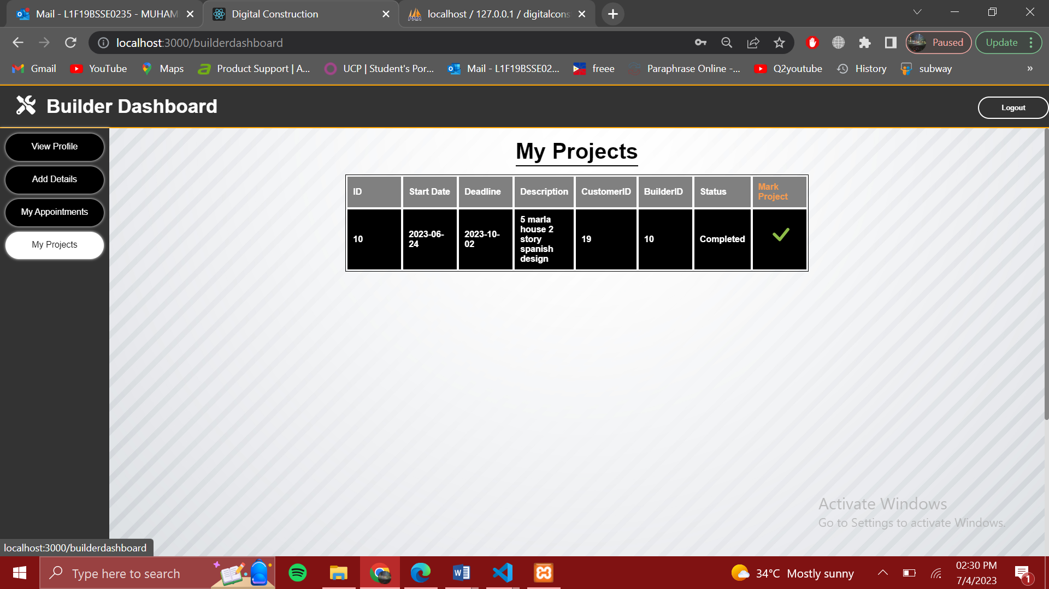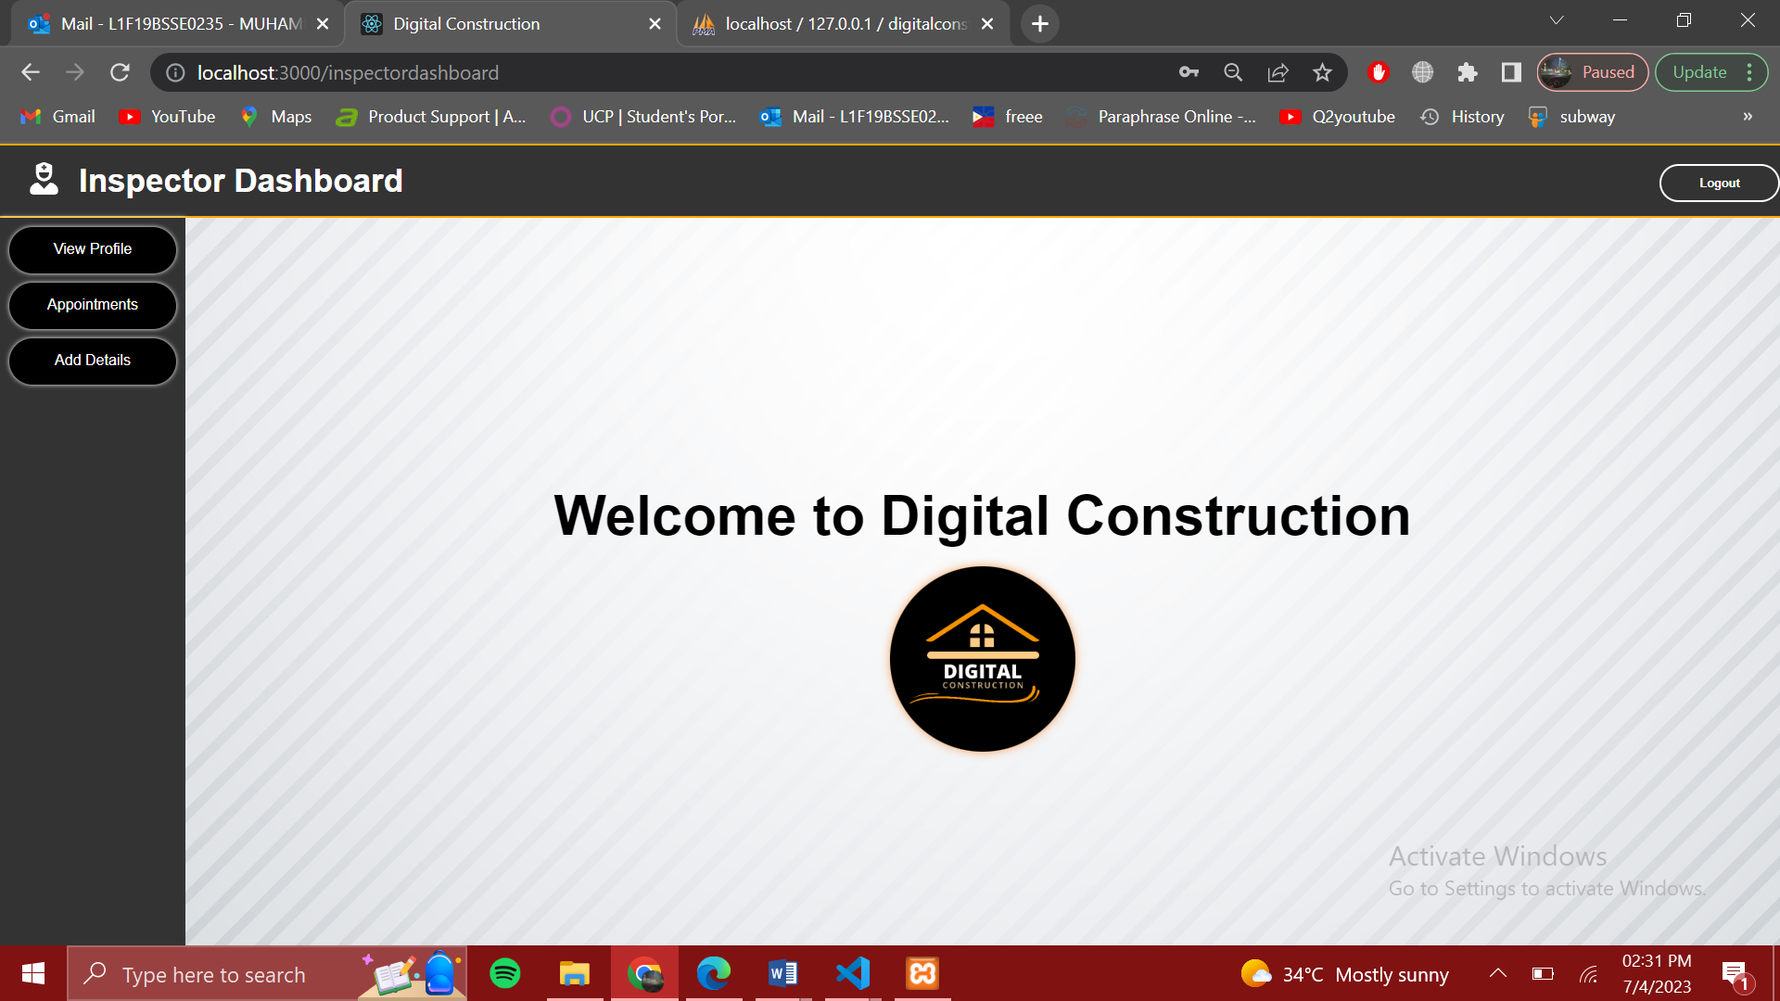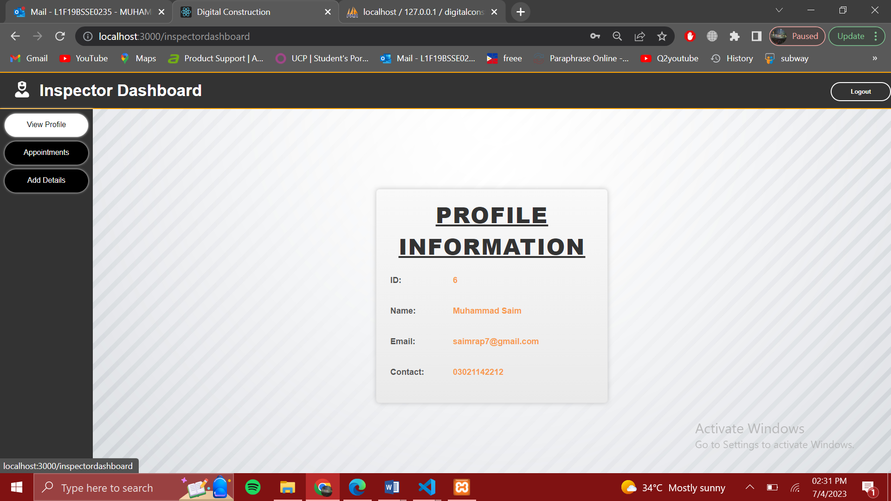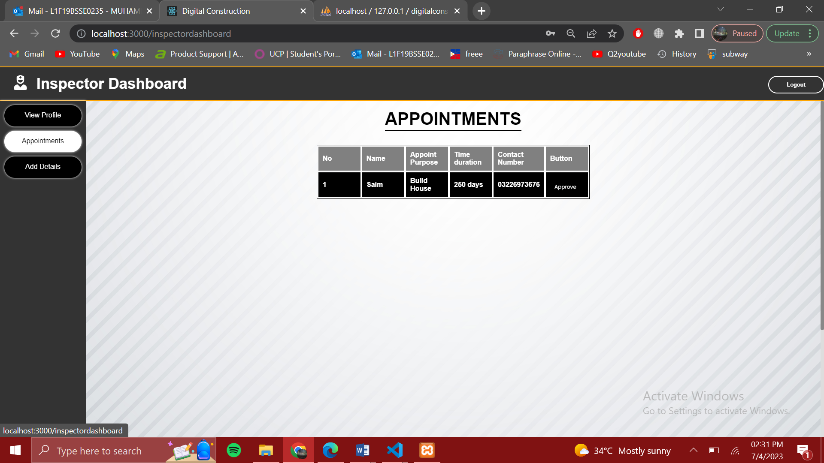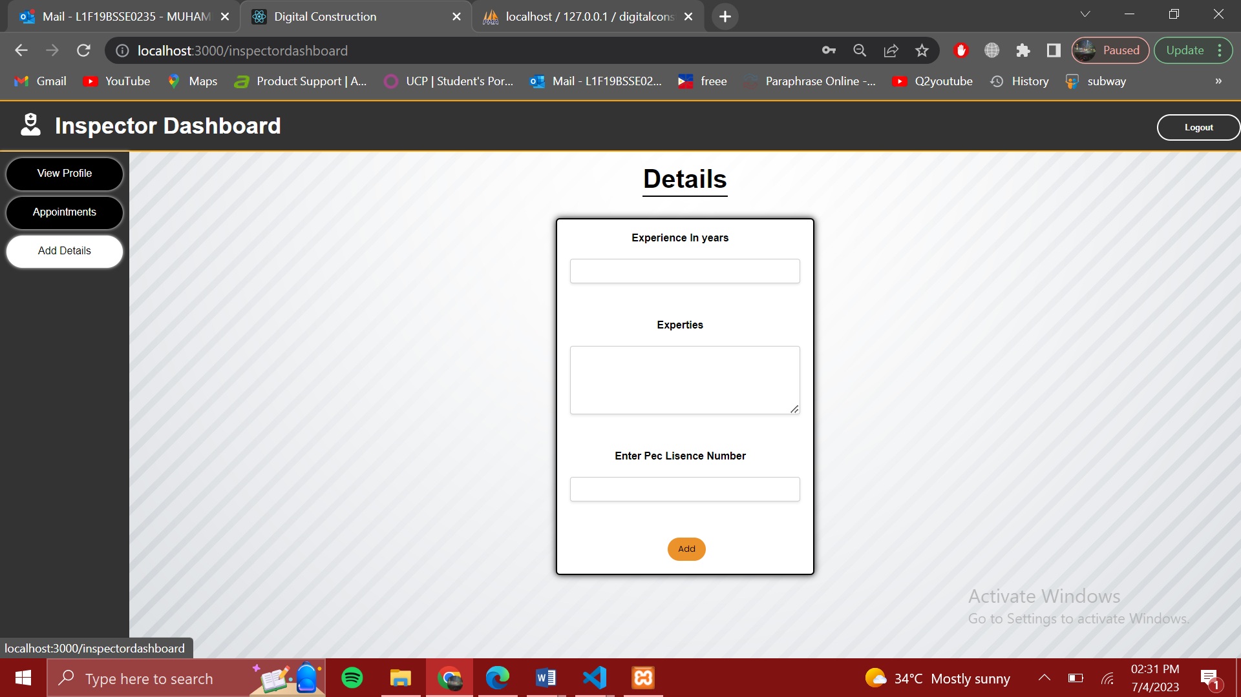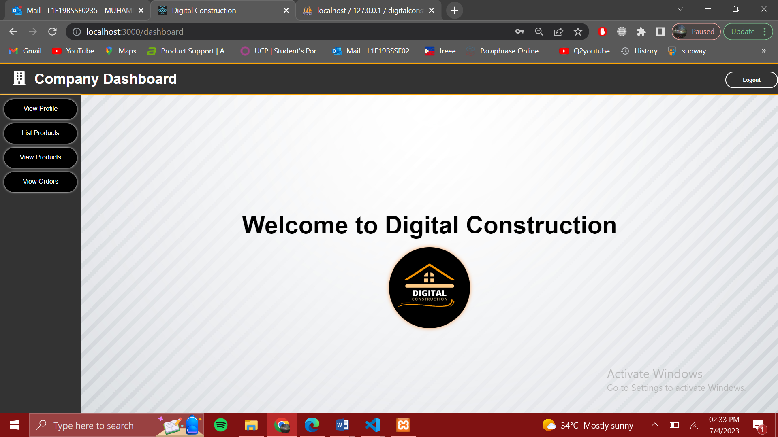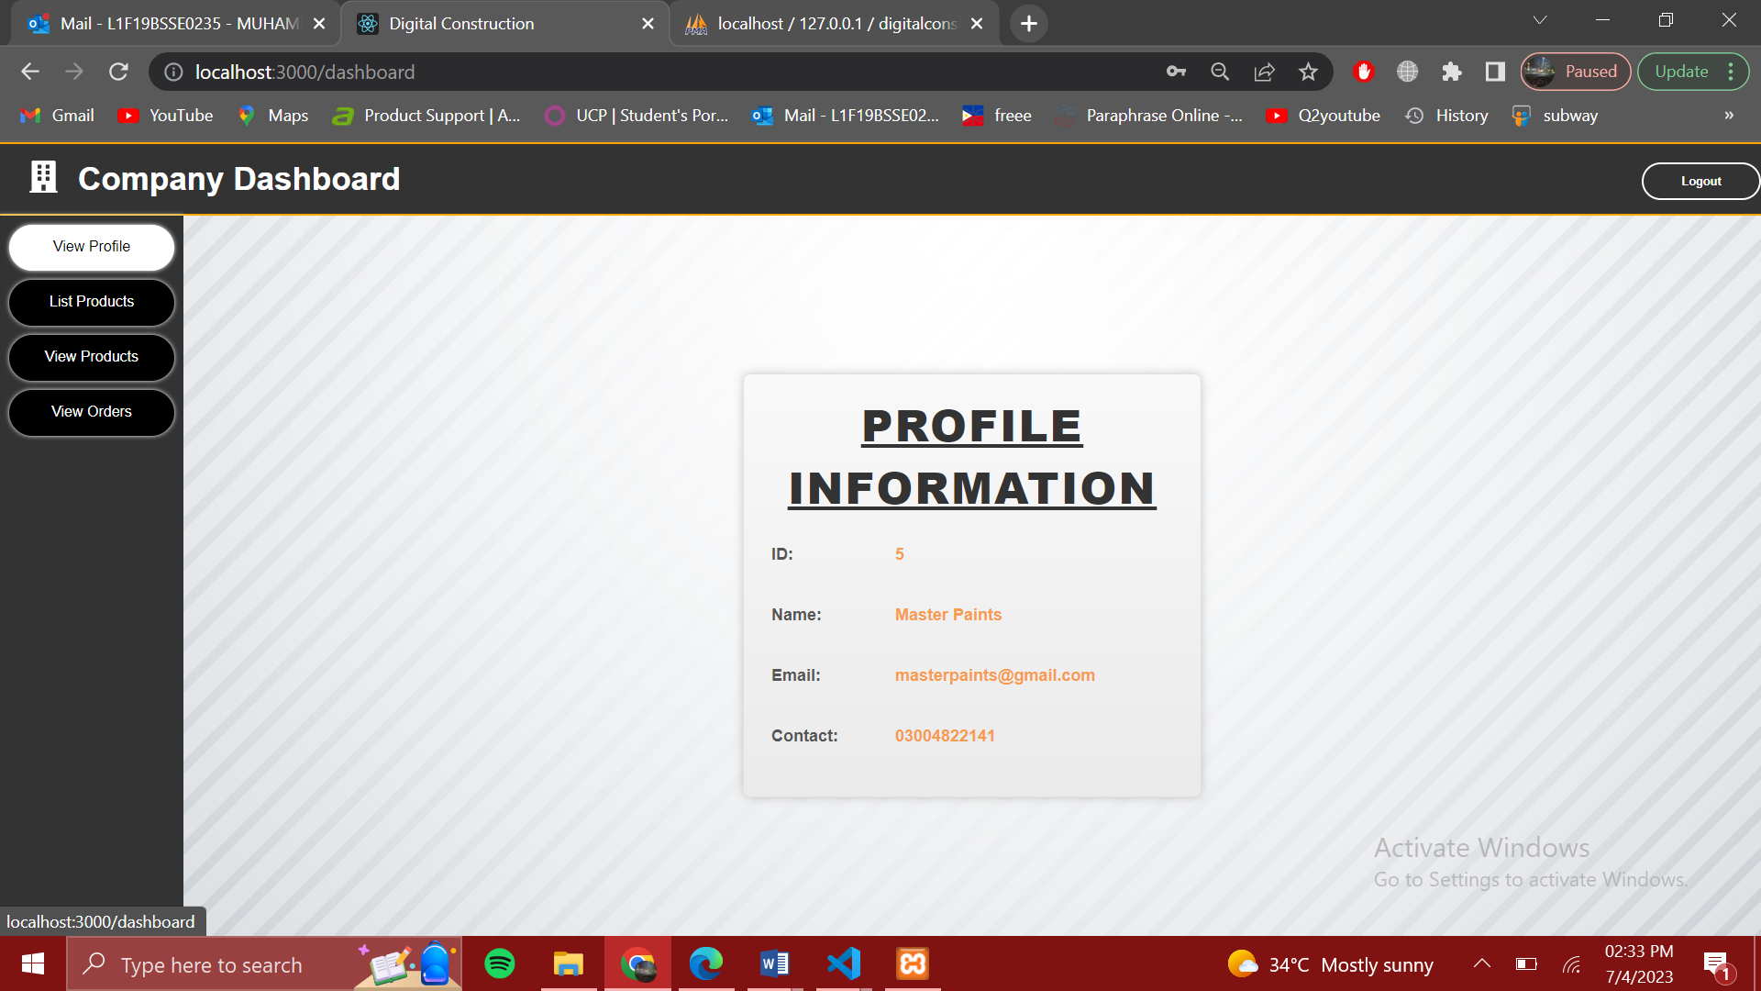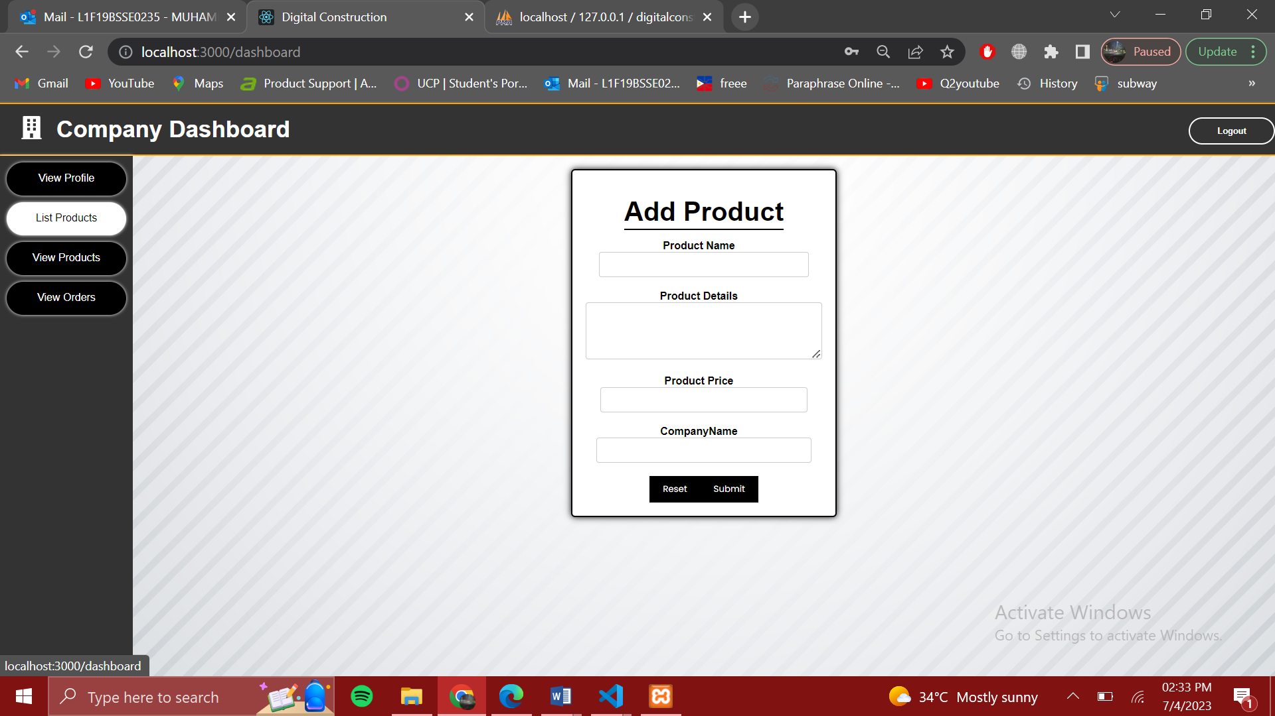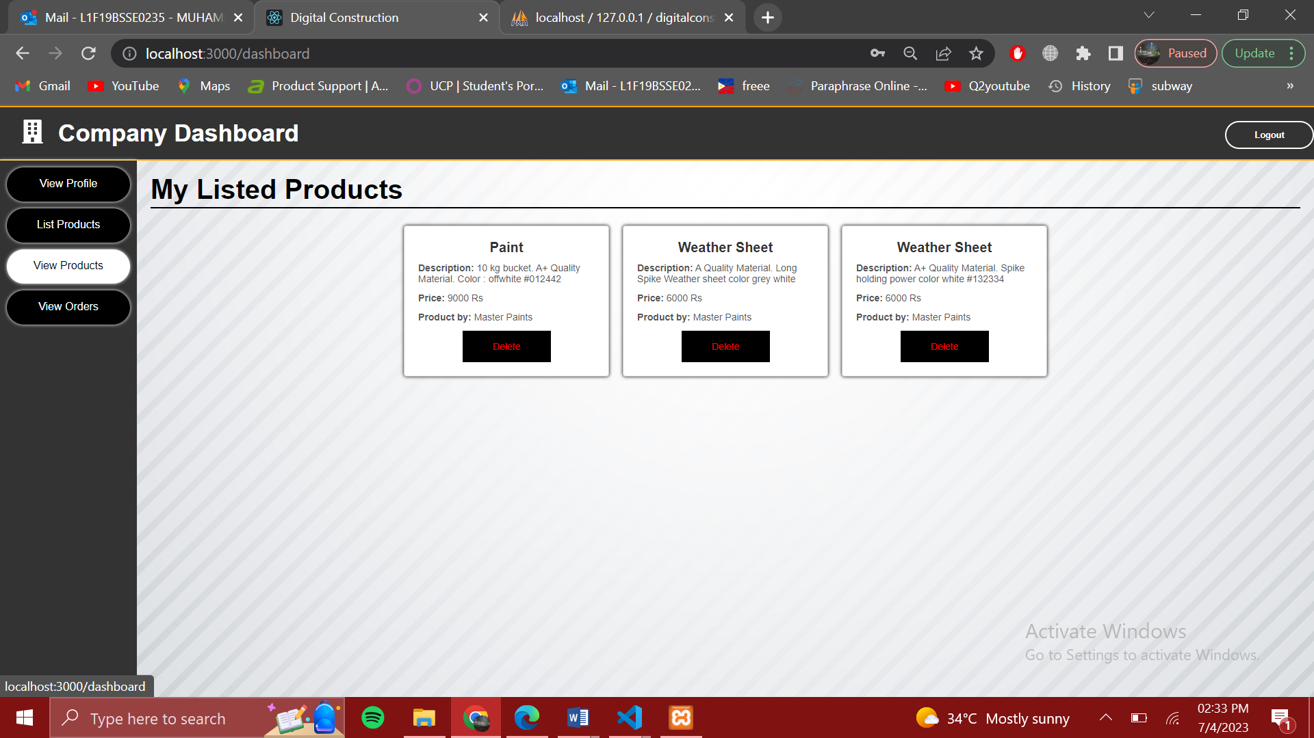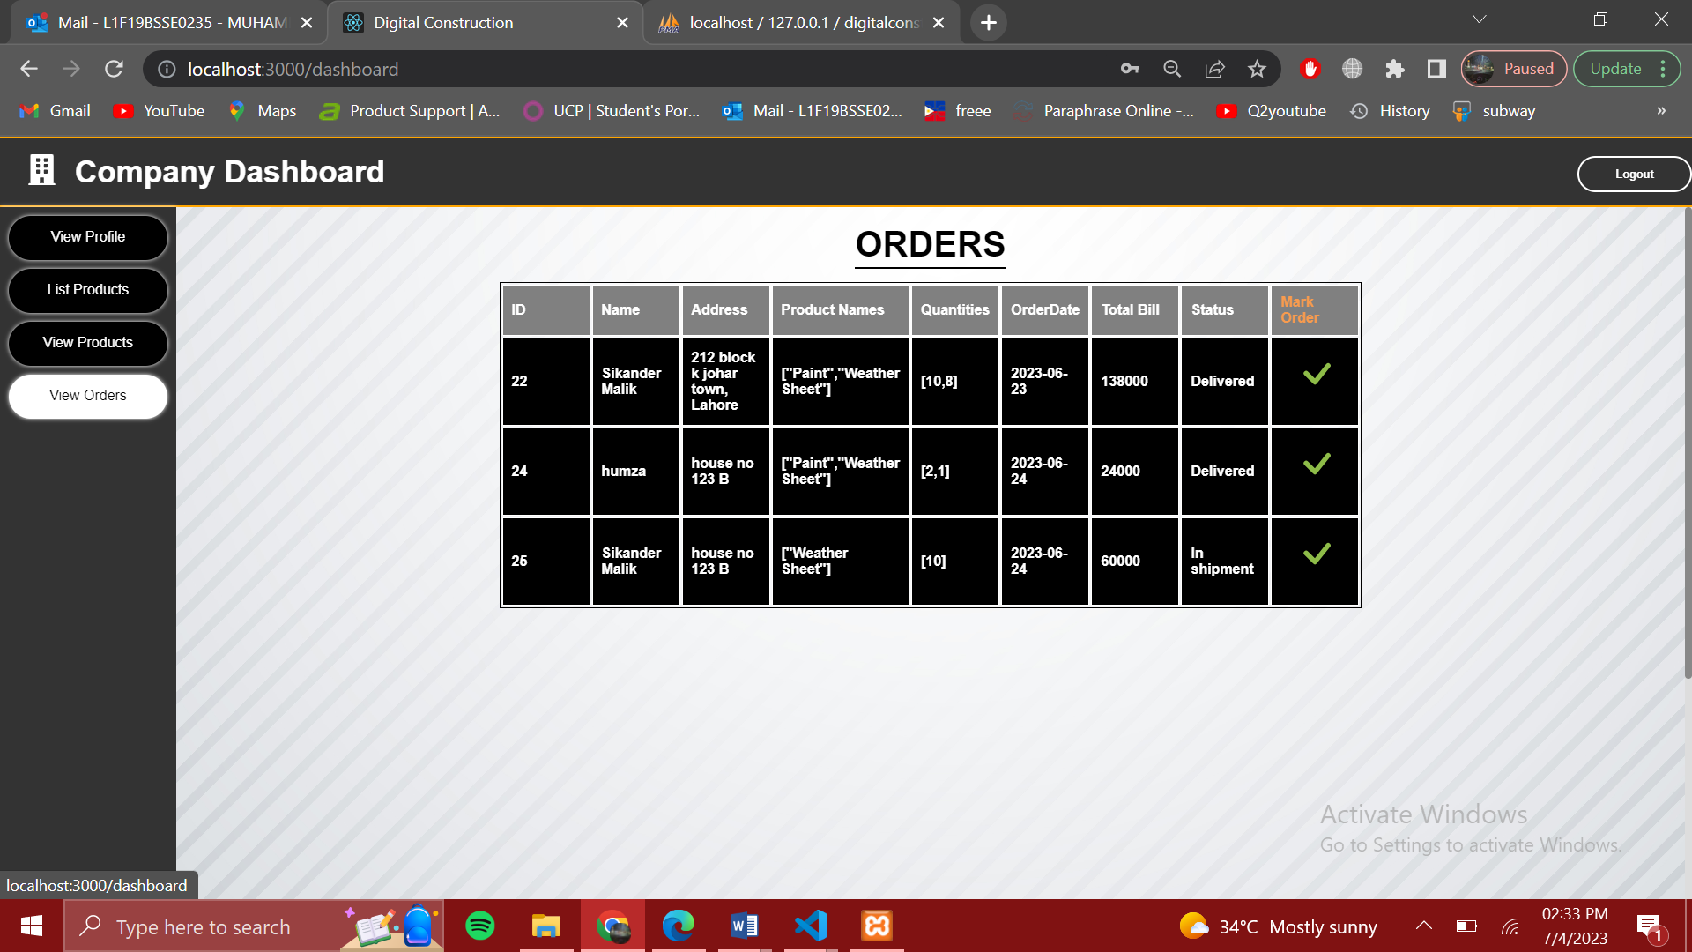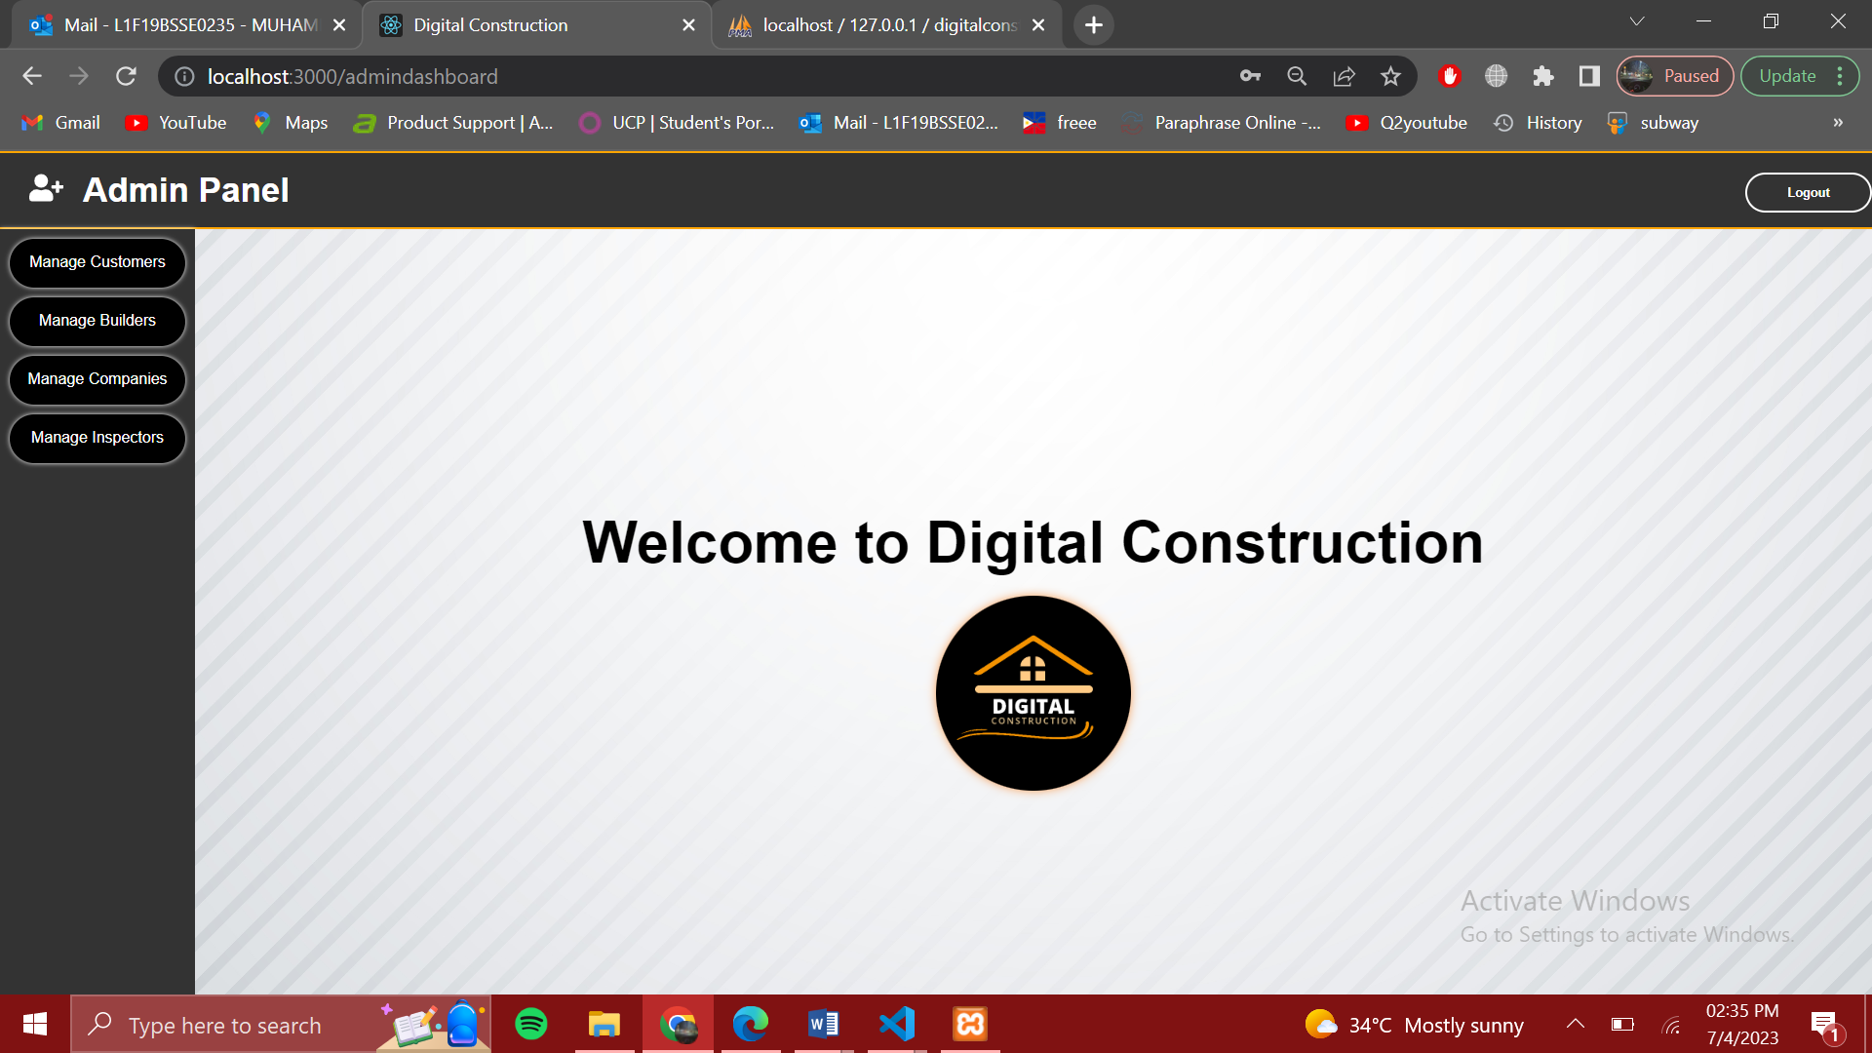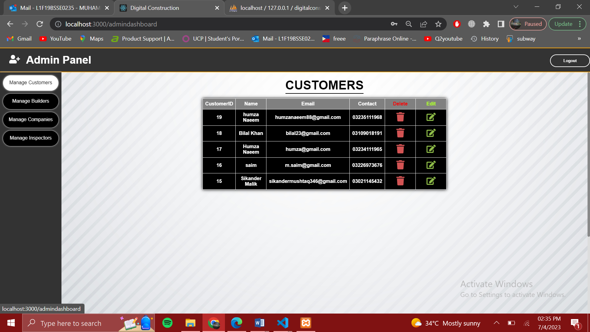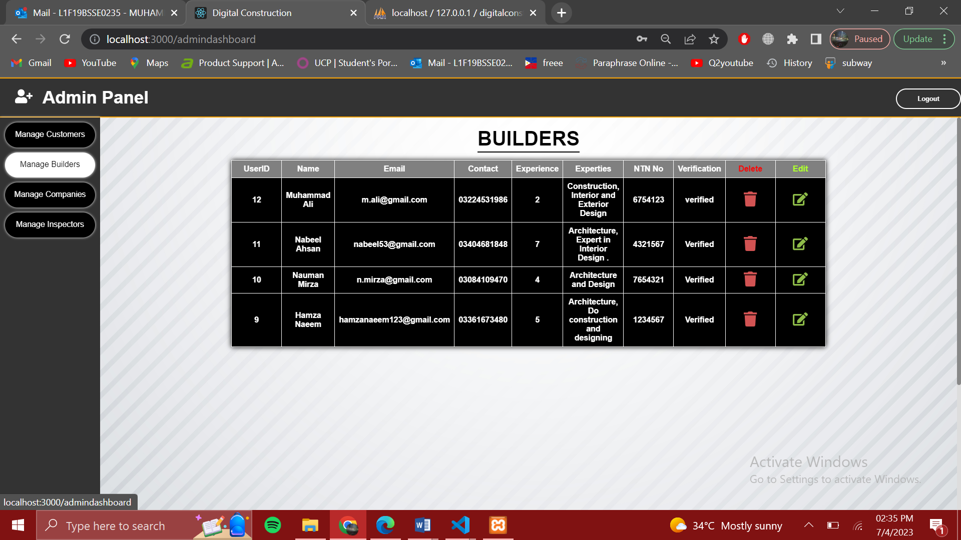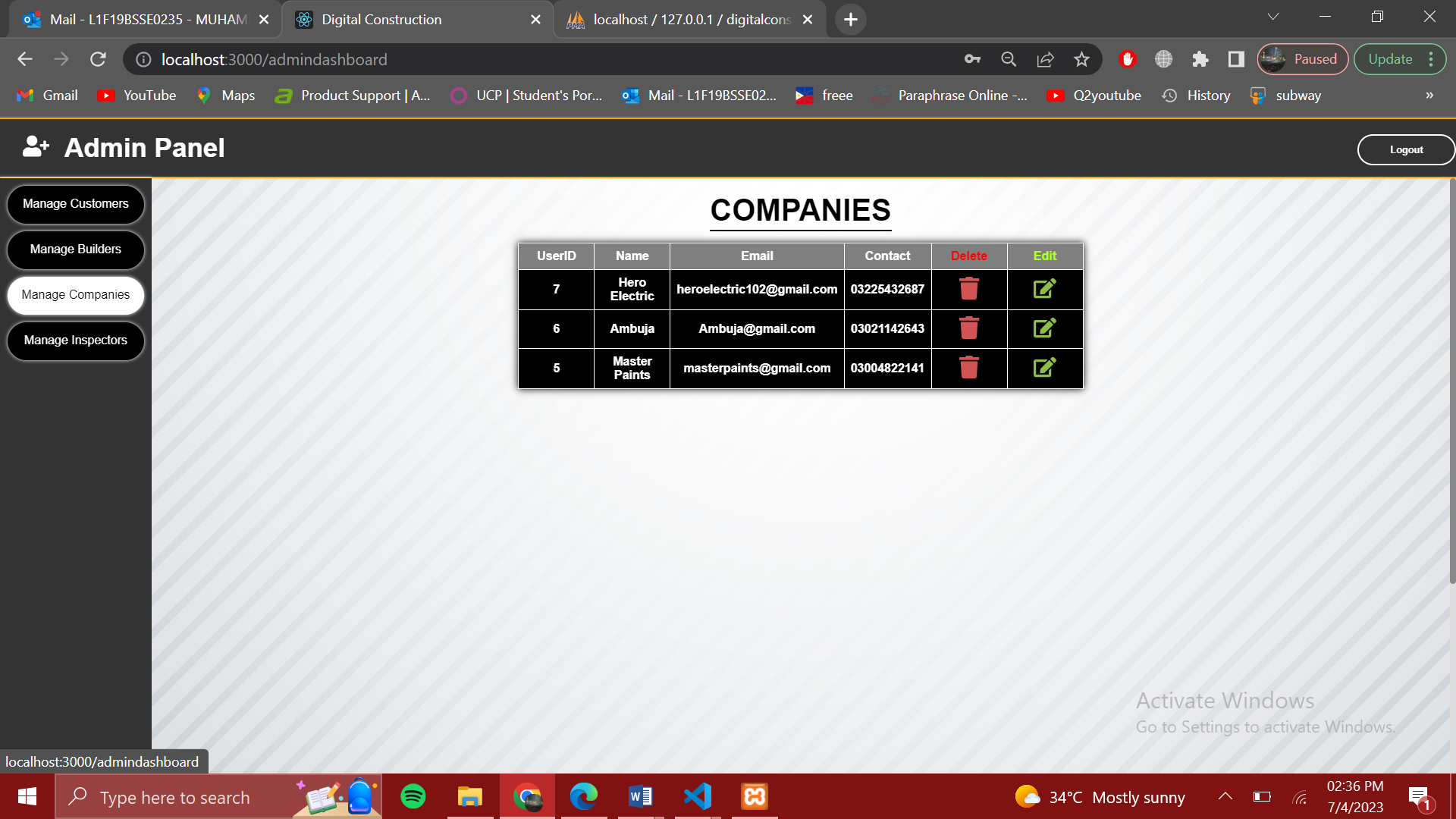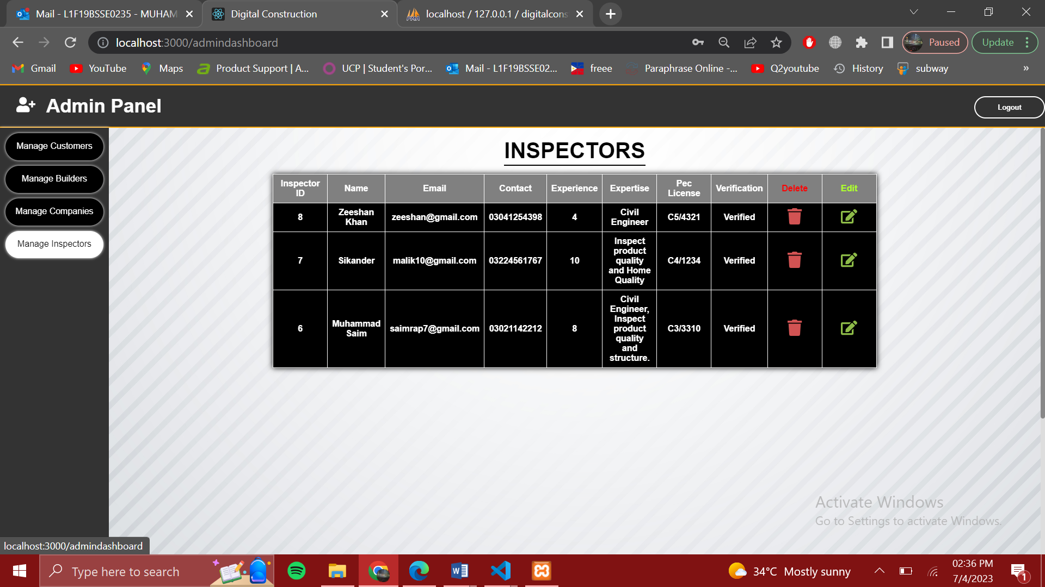

# Screenshots/Prototype

## Workflow

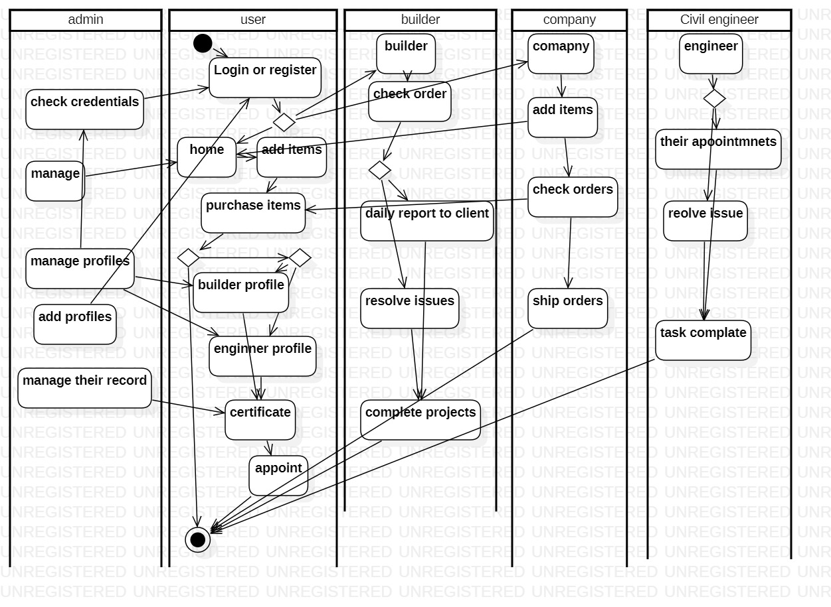

## Screens



## Additional Information

Digital construction will work in the sector of the growth of construction. Its an web application which have user friendly interface and this web appication access thorugh website. All the front end of the project is build on React Js. All the users profile has there different dashboard. Frond end is fully completed. We work on Node js there our systems not support the Node js and sockets so we decide All the Backend is on latravel. Front end is attached with laravel. This is not our design we still corking to improve the front end desgin. Authenication is done by JWT. All the users proform there own functionality.

# Other Design Details

Frond end is fully completed. We work on Node js there our systems not support the Node js and sockets so we decide All the Backend is on latravel. Front end is attached Through API with laravel. This is not our final design we still to improve the front end desgin.

# Test Specification and Results

## Test Case Specification

TC-1

|  |  |
| --- | --- |
| **Identifier** | TC-1 |
| **Related requirements(s)** | User Authentication |
| **Short description** | Ensure that only authorized users can access the app by testing the user authentication process. Test different scenarios, such as logging in with valid and invalid credentials, logging out, sign-in, sign-up. |
| **Pre-condition(s)** | Digital Construction homepage was already loaded. |
| **Input data** | Enter valid user email and password required |
| **Detailed steps** | * If user have account for log in. * Otherwise Sign up account first. * Use verify email and password to Sign up. * Then log in account. |
| **Expected result(s)** | Admin/Users should be navigate to their dashboard page |
| **Post-condition(s)** | Admin/Users should successfully Sign up. |
| **Actual result(s)** | Admin/User should be navigate to dashboard after login. |
| **Test Case Result** | Pass |

TC-2

|  |  |
| --- | --- |
| **Identifier** | TC-2 |
| **Related requirements(s)** | Sigup |
| **Short description** | A registration process for new users to create an account and gain access to a system, ensuring successful account creation and login functionality. |
| **Pre-condition(s)** | The system is accessible and functional, with a registration form available for new users to enter their details, and no existing user account with the same credentials should already exist in the system. |
| **Input data** | Enter username, contact number, email and password |
| **Detailed steps** | * Open the website Home page digital construction * Press on get started * Fill all the details and select the user |
| **Expected result(s)** | User successfully create there account |
| **Post-condition(s)** | The user account is successfully created and functional, allowing the user to login to the system using the registered credentials. |
| **Actual result(s)** | User can successfully create there account. |
| **Test Case Result** | Pass |

TC-3

|  |  |
| --- | --- |
| **Identifier** | TC-3 |
| **Related requirements(s)** | Project creation |
| **Short description** | The process of creating a new project by ensuring that all necessary fields and information are captured and that the project is saved correctly |
| **Pre-condition(s)** | All relevant fields already filled and the home page was loaded. |
| **Input data** | Complete all relevant fields such as Project type, Description, Duration, and total budget |
| **Detailed steps** | * User have account for log in or do sign-up. * Open appoint builder * Go to the request appointment * User have to fill all required fields with authenticity. |
| **Expected result(s)** | User should be navigate to Project creation page |
| **Post-condition(s)** | User should successfully create project. |
| **Actual result(s)** | User should be navigate to Project creation page |
| **Test Case Result** | Pass |

TC-4

|  |  |
| --- | --- |
| **Identifier** | TC-4 |
| **Related requirements(s)** | Project accept or reject By builder |
| **Short description** | Builder can accept or reject the appointment of the customer. All the details builder see then they accept or reject. |
| **Pre-condition(s)** | An appointment request is received and visible in the system for the user with the appropriate access level. The user has the necessary permissions to accept or reject appointment requests. |
| **Input data** | Builder has to preform they are accept or reject the customer appointment. |
| **Detailed steps** | * Builder have account and they login. * Check their appointments * Read all the details * Now they have to accept or reject appointment. |
| **Expected result(s)** | If Builder accept they show to customer. If they reject the appointment is discard. |
| **Post-condition(s)** | Builder should successfully accept request. |
| **Actual result(s)** | Builder accept request now show to the pending request of the customer. |
| **Test Case Result** | Pass |

TC-5

|  |  |
| --- | --- |
| **Identifier** | TC-5 |
| **Related requirements(s)** | Customer conform order |
| **Short description** | The process of place order last conformation by the customer they have to place. |
| **Pre-condition(s)** | The customer is logged into their account on the platform or website. The customerhas press the place for conform there order. |
| **Input data** | Open there account and press on place to conform the order |
| **Detailed steps** | * User have account for log in. * Open Request appointments. * Press on place button for conform. |
| **Expected result(s)** | Order is show to builder side. |
| **Post-condition(s)** | User should successfully give project. |
| **Actual result(s)** | Order is place to builder |
| **Test Case Result** | Pass |

TC-6

|  |  |
| --- | --- |
| **Identifier** | TC-6 |
| **Related requirements(s)** | Builder complete order |
| **Short description** | Builder can mark complete when project is complete. |
| **Pre-condition(s)** | An appointment request is received and visible in the system for the user with the appropriate access level. The user has the necessary permissions to complete project. |
| **Input data** | Builder has to preform they are complete the customer project. |
| **Detailed steps** | * Builder have account and they login. * Go to the My project * After complete the project they mark complete project. |
| **Expected result(s)** | Status of the project is completed |
| **Post-condition(s)** | Builder should successfully mark complete project. |
| **Actual result(s)** | Status is show complete on builder side and customer side. |
| **Test Case Result** | Pass |

TC-7

|  |  |
| --- | --- |
| **Identifier** | TC-7 |
| **Related requirements(s)** | Purchase item |
| **Short description** | A test case to verify the successful purchase of an item from an online platform or store, ensuring that the items add to cart successfully including and confirmation, is completed without any issues. |
| **Pre-condition(s)** | The item to be purchased is available and visible for selection. The customer is logged into their account on the online platform or store. |
| **Input data** | Customer's account information. Item details. Shipping details |
| **Detailed steps** | * User have account for log in. * Otherwise Sign up account first. * Go to add product. And add items * Go to cart add there details and place your order. |
| **Expected result(s)** | Order is place to company side. |
| **Post-condition(s)** | The item is successfully purchased in the system. |
| **Actual result(s)** | Order is successfully placed. |
| **Test Case Result** | Pass |

TC-8

|  |  |
| --- | --- |
| **Identifier** | TC-8 |
| **Related requirements(s)** | Company add items |
| **Short description** | A test case to verify the successful addition of a new item to a company's inventory or product catalog, ensuring that the item is correctly added with accurate details and is visible for customers to purchase. |
| **Pre-condition(s)** | The company has a functional system or platform for managing inventory and adding new items. The user performing the test case has the necessary permissions and access level to add items. |
| **Input data** | Company add the all the details of there product in details. |
| **Detailed steps** | * User have account for log in. * Otherwise Sign up account first. * Go to add product. And add items * Fill all the relevant information of the product. |
| **Expected result(s)** | Item is added and show to customers. |
| **Post-condition(s)** | The new item is successfully added to the company's inventory or product catalog. |
| **Actual result(s)** | Item is successfully added and display to the customers. |
| **Test Case Result** | Pass |

TC-9

|  |  |
| --- | --- |
| **Identifier** | TC-9 |
| **Related requirements(s)** | Appoint inspector |
| **Short description** | A test case to verify the successful appointment of an inspector to a specific task or project, ensuring that the selected inspector is assigned the appropriate responsibilities and has the necessary access and permissions to fulfill their role effectively. |
| **Pre-condition(s)** | The system has a list of available inspectors with their respective qualifications and availability. A task or project exists in the system that requires an inspector to be appointed. |
| **Input data** | Customer see all the inspectors and appoint according to them. |
| **Detailed steps** | * Customer open website and login. * Go to appoint inspector * See all the inspectors |
| **Expected result(s)** | Customer appoint the inspector |
| **Post-condition(s)** | An inspector is successfully appointed to the specified task or project. |
| **Actual result(s)** | Customer successfully appoint the inspector |
| **Test Case Result** | Pass |

TC-10

|  |  |
| --- | --- |
| **Identifier** | TC-10 |
| **Related requirements(s)** | Inspector approve |
| **Short description** | A test case to verify the successful approval of a customer request by an inspector, ensuring that the request is reviewed, assessed, and either approved. |
| **Pre-condition(s)** | The inspector has the necessary permissions and access level to review and approve customer requests. |
| **Input data** | Inspector see all the details of the customer then they approve. |
| **Detailed steps** | * Inspector open website and login. * Go to appointments. * See all the requests and approve |
| **Expected result(s)** | Inspector approve customer request |
| **Post-condition(s)** | The inspector reviews the customer request and provides a decision based on the established criteria. |
| **Actual result(s)** | Inspector successfully approve the request. |
| **Test Case Result** | Pass |

TC-11

|  |  |
| --- | --- |
| **Identifier** | TC-11 |
| **Related requirements(s)** | Company order |
| **Short description** | A test case to verify the successful viewing of customer orders by the company, ensuring that the company can access and review order details, track order statuses, and manage the fulfillment process efficiently. |
| **Pre-condition(s)** | The company has a functional system or platform for managing orders. There are existing customer orders in the system for the company to view. |
| **Input data** | Existing customer orders in the system to be viewed. |
| **Detailed steps** | * Company open website and login. * Go to orders. * See the order and mark order |
| **Expected result(s)** | Order status is delivered |
| **Post-condition(s)** | The company successfully accesses the list of customer orders. |
| **Actual result(s)** | Order status is delivered in the status field. |
| **Test Case Result** | Pass |

TC-12

|  |  |
| --- | --- |
| **Identifier** | TC-12 |
| **Related requirements(s)** | Admin manage customer |
| **Short description** | A test case to verify the successful management of customer accounts by an admin, ensuring that the admin can perform various actions such as delete customer and edit details of the user. |
| **Pre-condition(s)** | The admin has the necessary permissions and access level to manage customer accounts. The system or platform has a functional interface for admin account management. |
| **Input data** | Edit customer details edit there name, email, contact. |
| **Detailed steps** | * Admin open website and login. * Go to manage customers * Edit specific of the customer detail or delete. |
| **Expected result(s)** | Delete or edit the customer details. |
| **Post-condition(s)** | The admin successfully performs customer management actions such as updating, or deleting customer accounts. |
| **Actual result(s)** | Successfully Delete or edit the customer details. |
| **Test Case Result** | Pass |

TC-13

|  |  |
| --- | --- |
| **Identifier** | TC-13 |
| **Related requirements(s)** | Admin manage Builders |
| **Short description** | A test case to verify the successful management of customer accounts by an admin, ensuring that the admin can perform various actions such as delete builder’s and edit details of the user. |
| **Pre-condition(s)** | The admin has the necessary permissions and access level to manage customer accounts. The system or platform has a functional interface for admin account management. |
| **Input data** | Edit Builder’s details edit there name, email, contact. And add there FBR number or add their status of verified. |
| **Detailed steps** | * Admin open website and login. * Go to manage builder * Edit specific of the customer detail or delete. |
| **Expected result(s)** | Delete or edit the customer details. |
| **Post-condition(s)** | The admin successfully performs builder management actions such as updating, or deleting Builder accounts. |
| **Actual result(s)** | Successfully Delete or edit the builder details. |
| **Test Case Result** | Pass |

TC-14

|  |  |
| --- | --- |
| **Identifier** | TC-14 |
| **Related requirements(s)** | Admin manage Inspector |
| **Short description** | A test case to verify the successful management of customer accounts by an admin, ensuring that the admin can perform various actions such as delete Inspector and edit details of the user. |
| **Pre-condition(s)** | The admin has the necessary permissions and access level to manage customer accounts. The system or platform has a functional interface for admin account management. |
| **Input data** | Edit customer details edit there name, email, contact, experience, expertise, and add Verification number and status. |
| **Detailed steps** | * Admin open website and login. * Go to manage customers * Edit specific of the Inspector detail or delete. |
| **Expected result(s)** | Delete or edit the Inspector details. |
| **Post-condition(s)** | The admin successfully performs customer management actions such as updating, or deleting Inspector accounts. |
| **Actual result(s)** | Successfully Delete or edit the inspector details. |
| **Test Case Result** | Pass |

TC-15

|  |  |
| --- | --- |
| **Identifier** | TC-15 |
| **Related requirements(s)** | Admin manage company |
| **Short description** | A test case to verify the successful management of customer accounts by an admin, ensuring that the admin can perform various actions such as delete Company and edit details of the user. |
| **Pre-condition(s)** | The admin has the necessary permissions and access level to manage customer accounts. The system or platform has a functional interface for admin account management. |
| **Input data** | Edit customer details edit there name, email, contact, experience, expertise, and add Verification number and status. |
| **Detailed steps** | * Admin open website and login. * Go to manage customers * Edit specific of the company detail or delete. |
| **Expected result(s)** | Delete or edit the company details. |
| **Post-condition(s)** | The admin successfully performs customer management actions such as updating, or deleting company accounts. |
| **Actual result(s)** | Successfully Delete or edit the company details. |
| **Test Case Result** | Pass |

## Summary of Test Results

Table 6.2: Summary of All Test Results

|  |  |  |  |  |
| --- | --- | --- | --- | --- |
| **Module Name** | Test cases run | Number of defects found | Number of defects corrected so far | Number of defects still need to be corrected |
| **USER** | TC1,TC2,TC3,TC5,TC7,TC9 | 7 | 7 | 0 |
| **BUILDER** | TC1,TC2,TC4,TC6 | 3 | 3 | 0 |
| **COMPANY** | TC1,TC2,TC8.TC11 | 2 | 2 | 0 |
| **INSPECTOR** | TC1,TC2,TC9,TC10 | 5 | 5 | 0 |
| **Admin** | TC12,TC13,TC14,TC15 | 2 | 2 | 0 |
| **Complete System** | 15 | 19 | 19 | 0 |

# Project Completion Status

Table 7.1: Project Completion Status

|  |  |
| --- | --- |
| **Module Name** | **Status**  (Complete, Partially Implemented, Not Implemented) |
| **Module 1 (User )** | Complete |
| **Module 2 (Builder)** | Complete |
| **Module 3 (Company)** | Complete |
| **Module 4 (Inspector)** | Complete |
| **Module 5 (Admin)** | Complete |

Table 7.2: Objective(s)/Target(s) Status

|  |  |  |
| --- | --- | --- |
| **Target/Objective** | **Status**  (Completed,  Partially Completed,  Not Completed) | **Reason(s)** |
| **Providing quality products** | Complete |  |
| **Ensuring transparency** | Complete |  |
| **Optimizing processes** | Complete |  |
| **Provide Verification** | Complete |  |
| **Leveraging digital technologies in the construction industry** | Complete |  |
| **Number of Targets Completed** | 5 |  |
| **Number of Targets Partially Completed** | 0 |  |
| **Number of Targets Not Completed** | 0 |  |

# 

# Deployment/Installation Guide

**Environment:**

Ensure that you have a suitable web server or hosting provider for your project.

Verify that the server meets the system requirements (e.g., supported programming languages, frameworks, and databases).

Set up any necessary dependencies, such as libraries or extensions required by your project.

**Codebase Setup:**

Clone or download the project's source code from the repository.

If applicable, create a configuration file (e.g., .env) and set the required environment variables, including database connection details, API keys, and any other project-specific configurations.

**Database Setup:**

Install and configure the required database server (e.g., MySQL).

Create a new database for your project.

Import any database schema or seed data provided with the project, if applicable.

**Dependency Management:**

Install the necessary dependencies using a package manager specific to your project (e.g., npm forreact.js projects, Composer for PHP projects).

Run the dependency installation command, which will download and install the required packages/modules.

Build and Compilation:

If your project requires a build or compilation step (e.g., for frontend assets), follow the instructions provided by the project to perform the build process.

**Web Server Configuration:**

Configure your web server (e.g., Apache, Nginx) to serve your project.

Set up the necessary virtual hosts, domain bindings, or server blocks to point to your project's directory.

Configure any required server settings, such as enabling URL rewriting or setting up SSL certificates.

**Application Setup:**

If your project requires additional setup steps (e.g., migrations, data seeding), refer to the project documentation for specific instructions.

Run any necessary setup or initialization commands provided by the project.

**Testing:**

Perform thorough testing to ensure that your project is functioning as expected in the deployment environment.

Test various features, user interactions, and data flows to identify and resolve any issues.

**Security and Permissions:**

Review and configure the necessary security settings for your project, such as file permissions, secure connections, and user authentication.

Implement any additional security measures recommended by the project or best practices.

**Monitoring and Maintenance:**

Set up monitoring and logging solutions to track the performance and errors of your deployed application.

Implement backup and disaster recovery procedures to protect your data.

Establish a maintenance plan to keep your project up to date with security patches, bug fixes, and new releases of dependencies.

# User Manual

User Manual: Digital Construction

Welcome to Digital Construction! This user manual will guide you through the features and functionality of our web-based project. Please read this manual carefully to make the most out of your experience.

**Table of Contents:**

Introduction

Getting Started

User Registration and Login

Dashboard Overview

Project Management

Collaboration Tools

Document Management

Reporting and Analytics

Support and Feedback

Frequently Asked Questions (FAQs)

Conclusion

**1. Introduction**

Digital Construction is a web-based project management platform designed specifically for the construction industry. It aims to streamline and enhance collaboration, document management, and reporting for construction projects.

**2. Getting Started**

To access Digital Construction, ensure you have a compatible web browser and a stable internet connection. Open the browser and navigate to the Digital Construction website.

**3. User Registration and Login**

If you're a new user, click on the "Sign Up" button on the homepage to create your account. Provide the required information and follow the instructions to complete the registration process.

If you're an existing user, enter your credentials (username/email and password) in the login section and click "Sign In" to access your account.

**4. Dashboard Overview**

Upon successful login, you'll be directed to the dashboard. The dashboard provides an overview of your ongoing projects, tasks, notifications, and recent activity. It serves as the central hub for your project management activities.

**5. Project Management**

Digital Construction offers robust project management capabilities. To create a new project, click on the "New Project" button on the dashboard. Provide project details such as name, description, start/end dates, and team members. Save the project to proceed.

Within a project, you can create tasks, assign them to team members, set deadlines, and track progress. Use the project calendar to visualize project milestones and deadlines.

**6. Collaboration Tools**

Digital Construction facilitates seamless collaboration among team members. Utilize the following tools for effective communication and coordination:

Discussion Boards: Create project-specific discussion boards to share ideas, ask questions, and collaborate with team members.

**7. Document Management**

Efficient document management is crucial in construction projects. Digital Construction offers the following features to manage project documents effectively:

Version Control: Maintain multiple versions of documents and track changes over time.

Access Control: Set permissions to control who can view, edit, and download documents.

**8. Reporting and Analytics**

Digital Construction provides comprehensive reporting and analytics capabilities. Generate reports on project progress, task completion, resource allocation, and more. Use analytics tools to gain insights and make data-driven decisions.

**9. Support and Feedback**

If you encounter any issues or have suggestions for improvement, click on the "Support" or "Feedback" section to reach out to the Digital Construction support team. They will assist you with troubleshooting and provide guidance.

**10. Frequently Asked Questions (FAQs)**

Refer to the "FAQs" section on the Digital Construction website for answers to commonly asked questions. The FAQs cover various topics, including account management, project setup, and troubleshooting.

**11. Conclusion**

Congratulations! You've now familiarized yourself with the key features and functionality of Digital Construction. Use this user manual as a reference whenever you need assistance. We hope this platform enhances your construction project management experience.

# References

1. Third party risk (Used for Safety requirements)

<https://partner-security.withgoogle.com/docs/webapp_requirements.html#third-partycontent>

1. Secure the environment (Used for secure environment)

<https://partner-security.withgoogle.com/docs/webapp_requirements.html#webenvironment>

1. Use the right Authorized (only authorized person use this web application)

<https://partner-security.withgoogle.com/docs/webapp_requirements.html#authentication>

1. People face problem while building home to find best constructor

<https://teamovercs.com/2019/10/builder-house-construction/>

1. Digital transformation

<https://www.hakunamatatatech.com/our-resources/blog/digital-transformation-in-construction-challenges-technologies-and-solution/>

1. Quality of material

<https://www.quickbase.com/blog/quality-control-in-construction>

# Project Summary Form

|  |  |
| --- | --- |
| **Name of Project** | Digital Construction |
| **Project Type** | Choose an item. |
| **Department** | FOIT |
| **Start Date** | 21 August, 2022 |
| **Completion Date** | 10 june,2023 |
| **Supervisor / Team Leader** | Muhammad Bilal Khan / Malik Sikander |
| **Team Members (if any)** | Humza Naeem  Muhammad Saim |
| **Funding Agency (if any)** | Self |
| **Amount of Funding (if any)** | Self |
| **Assign SDGs to Project** | Zero hunger, Decent work with Economic growth |
| **Motivation of Project** | Click or tap here to enter text. |
| **Practical / Potential Application** | Click or tap here to enter text. |
| **Abstract** | We are developing a web-based solution that addresses various challenges in the construction industry. Our application offers assistance in finding the best constructors, authenticating and documenting construction projects, providing up-to-date material rates, and supporting daily wagers. It aims to simplify the process for both customers and builders by offering comprehensive market information and connecting them with verified builders and verified materials. |
| **Key Technical Features** | Usability, Efficiency, Flexibility and Reliability. |
| **Projects Images / Screenshots** |  |

Appendix A: Glossary

UI: User Interface

MySQL: Database

User Interface (UI): The interface through which a user interacts with a computer program or application, typically through a graphical user interface (GUI).

Database: A collection of data stored and organized in a specific manner, allowing for efficient retrieval, insertion, and modification of data.

Appendix B: IV & V Report

**(Independent verification & validation)**

**IV & V Resource**

Name Signature

|  |  |  |  |  |  |
| --- | --- | --- | --- | --- | --- |
| **S#** | **Defect Description** | **Origin Stage** | **Status** | **Fix Time** | |
| **Hours** | **Minutes** |
| 1 | The issue including dependencies | Requirement implementation | Fixed | 27 hours | 1620 |
| 2 | Login Credentials match with signup | Testing | Fixed | 20 hours | 1200 |
| 3 |  |  |  |  |  |
| … |  |  |  |  |  |

**Table B.1: List of non-trivial defects**

This document has been adapted from the following:

1. Previous project templates at UCP
2. High-level Technical Design, Centers for Medicare & Medicaid Services. (www.cms.gov)